SERVICING MODULE TAWARRUQ RESTRUCTURING
Unit Test Document Version 1.1
MARCH 30, 2026

Document History
Author | Version | Date | Description
Muhammad Ali  Muhammad Asad | V1.0 | 17th MAR 2026 | Initial Document
Muhammad Asad | V1.1 | 30th MAR 2026 | Old arrangement early payoff amount through API screenshots updated

Contents
Old Arrangement Details 4
OLD Arrangement Early payoff amount 4
New / Restructure Arrangement Creation 6
New Application Details 6
New application creation 6
Qarar Response 8
Presales Queue 9
New Application Overview 9
Transact Simulation 10
Financial Details 10
Simah Details 11
Servicing Module 11
Application Approval 12
Offer Generation 14
Offer Acceptance 15
Application Details in Transact 16
STP Process 17
Bill Generation 18
Bill Payment 19
Contract 20
Promissory Note 22
STP Complete 23
New Arrangement 23
New Arrangement Accounting Entries 24
New Arrangement’s Repayment Account 24
Disbursement 25
Payoff of Old Arrangement 27
Closure of Old Arrangement with Accounting entries 35

Old Arrangement Details
Application ID: PPM9HB4
Contract amount: 40,000.00
Contract Tenor: 24 Months
Contract No / AA REF : AA251809L8NR
Old Maturity Date: 20270628

OLD Arrangement Early payoff amount
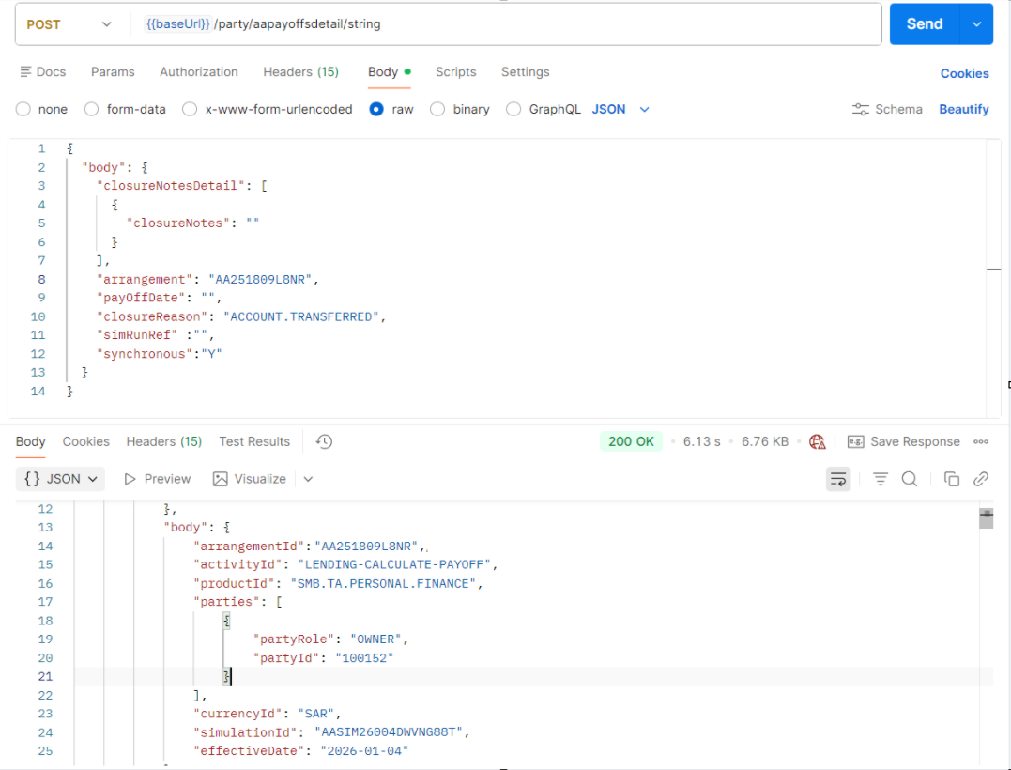
Early payoff simulation of old arrangement from API
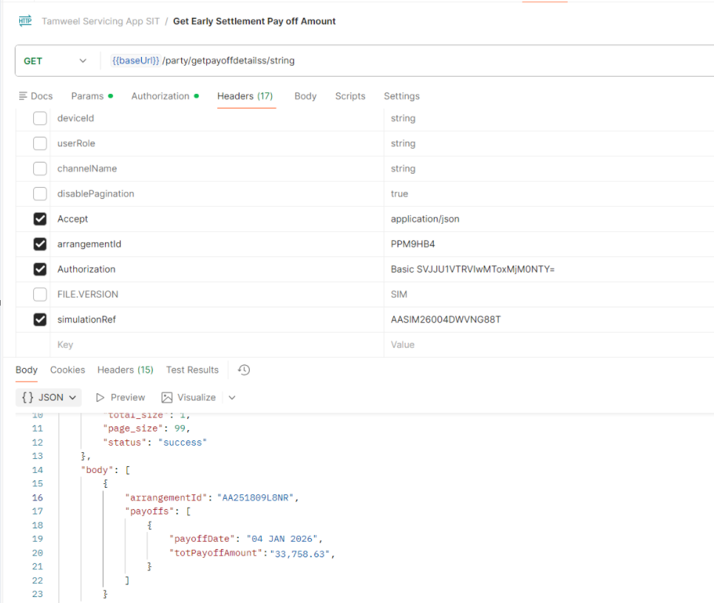
Early payoff amount of old arrangement

New / Restructure Arrangement Creation

New Application Details
Application ID: D8LVHQ9
Contract amount: 33,758.63.00
Contract Tenor: 24 Months

New application creation
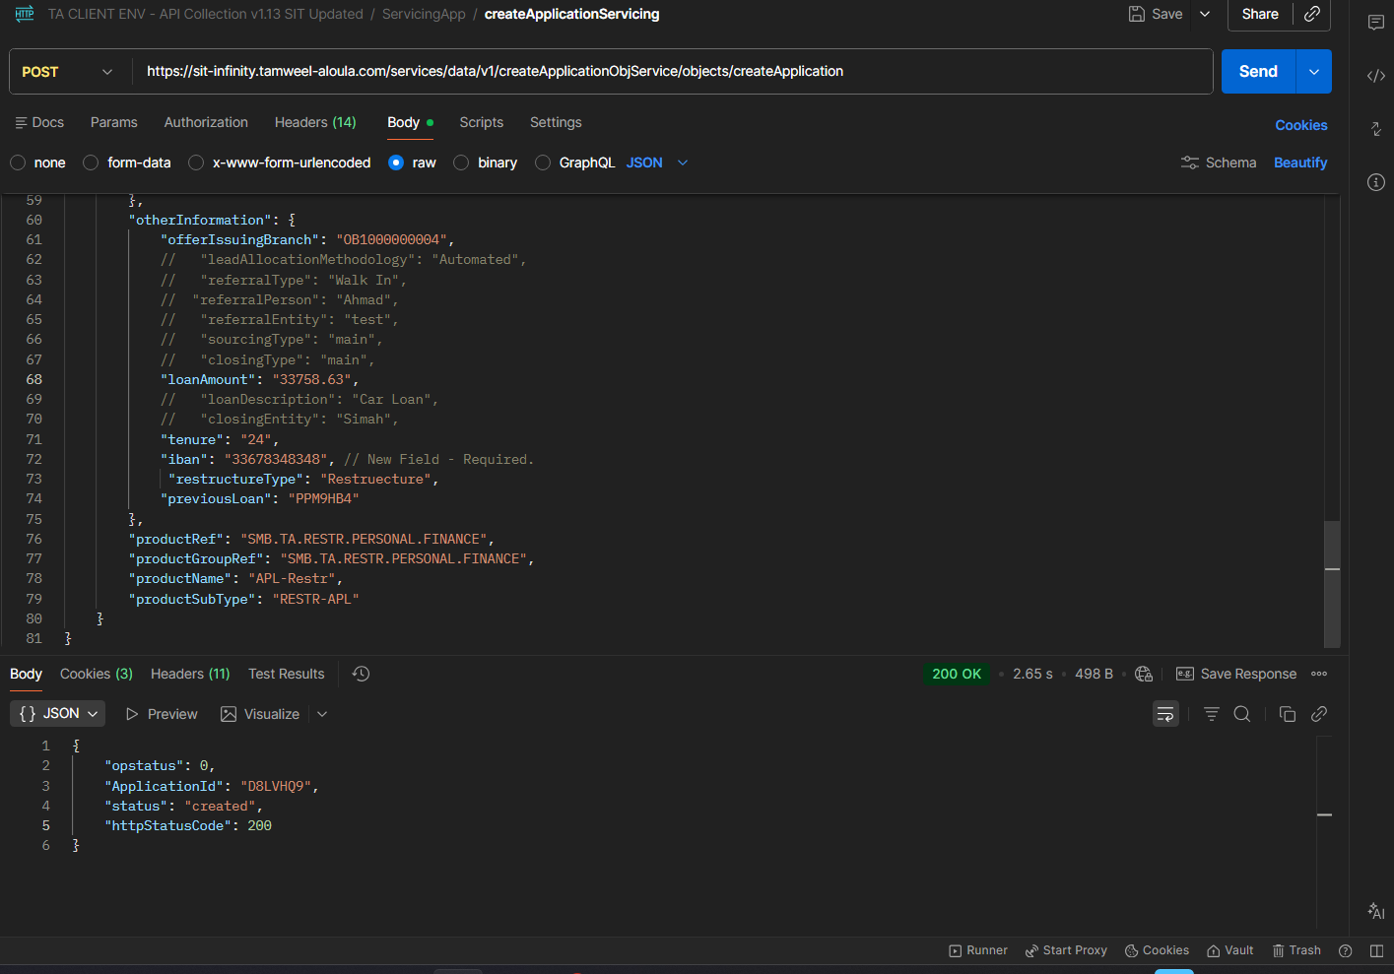
Application created through API
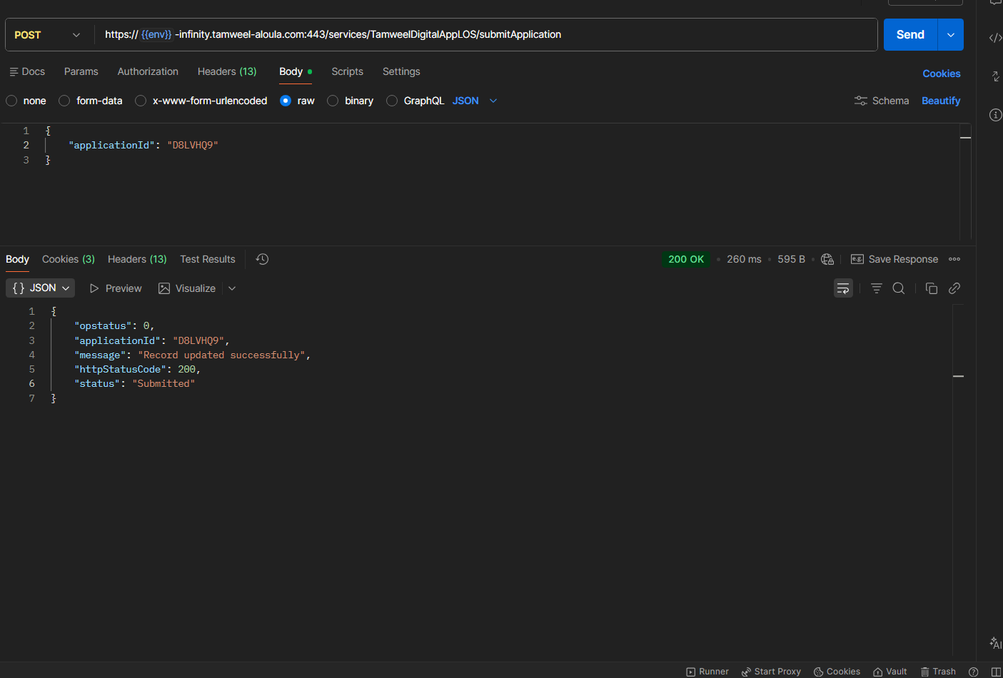
Application submission through API

Qarar Response
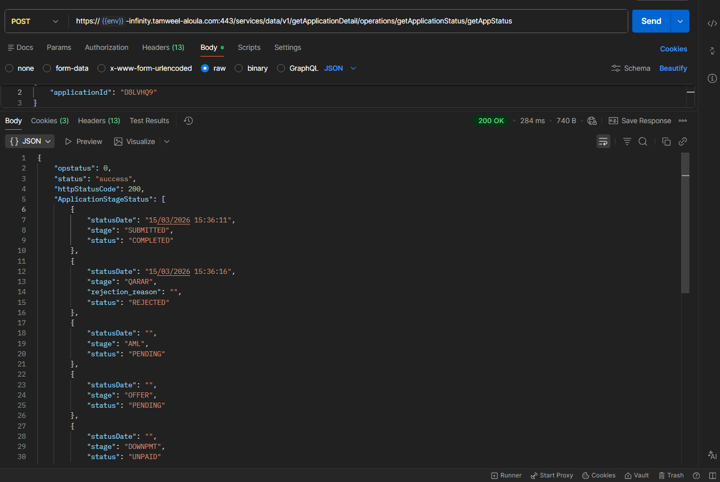
Qarar Respose received as Rejected

Presales Queue
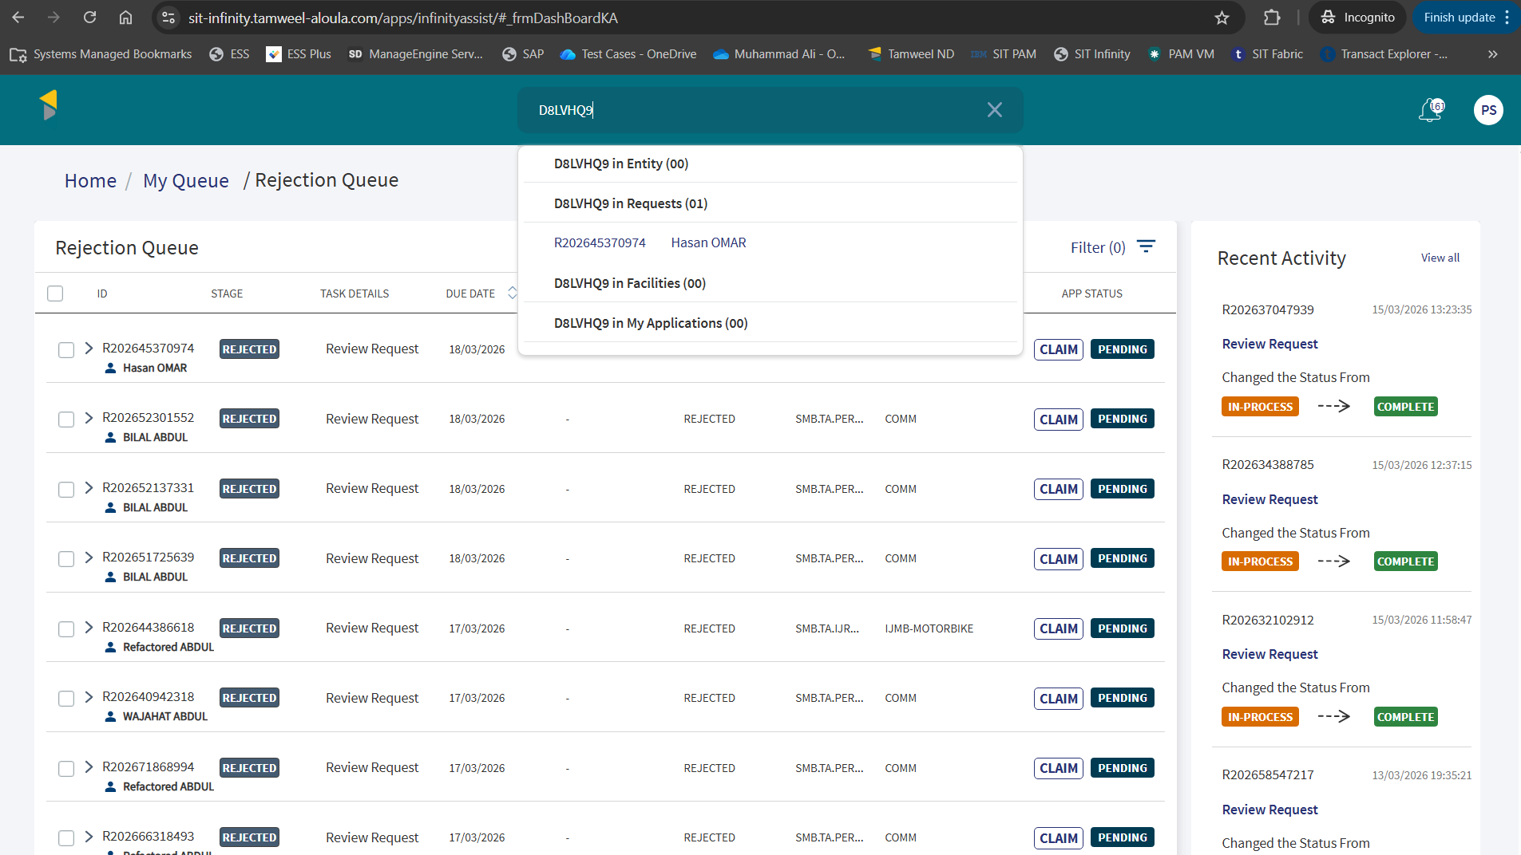
Application is visible in Presales Queue to claim

New Application Overview
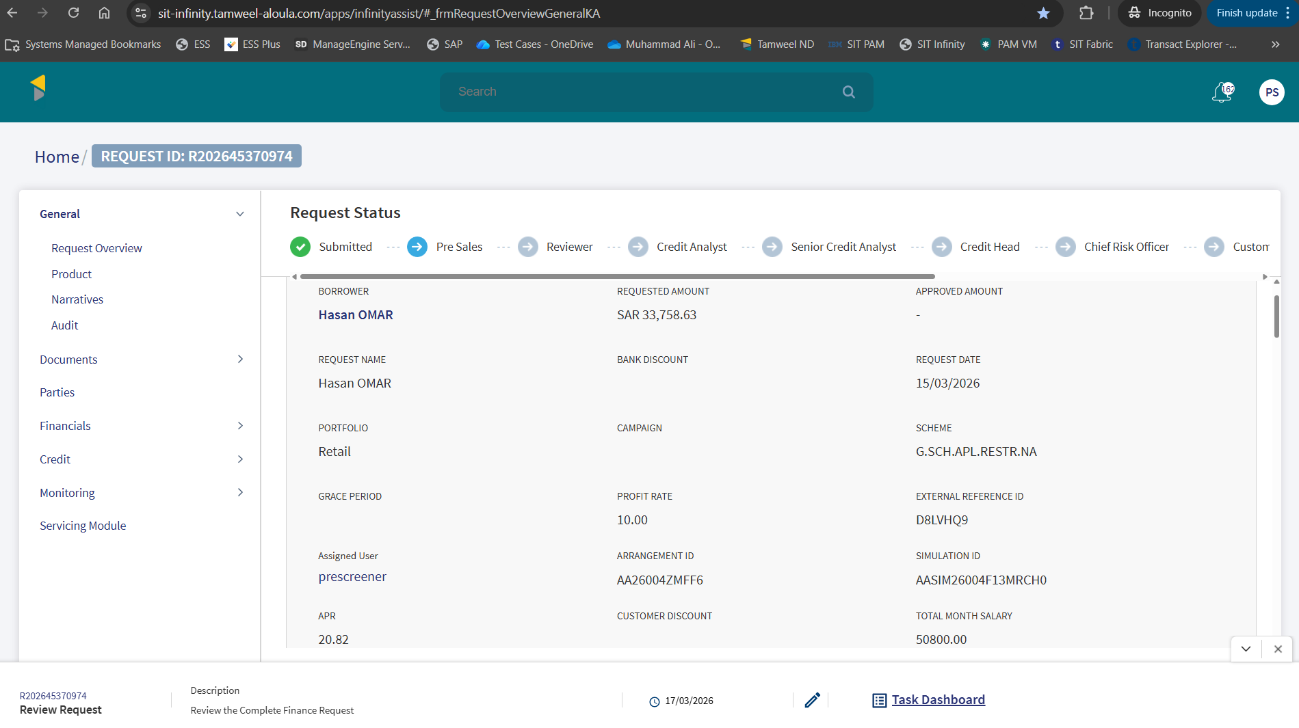
Request Overview Information

Transact Simulation
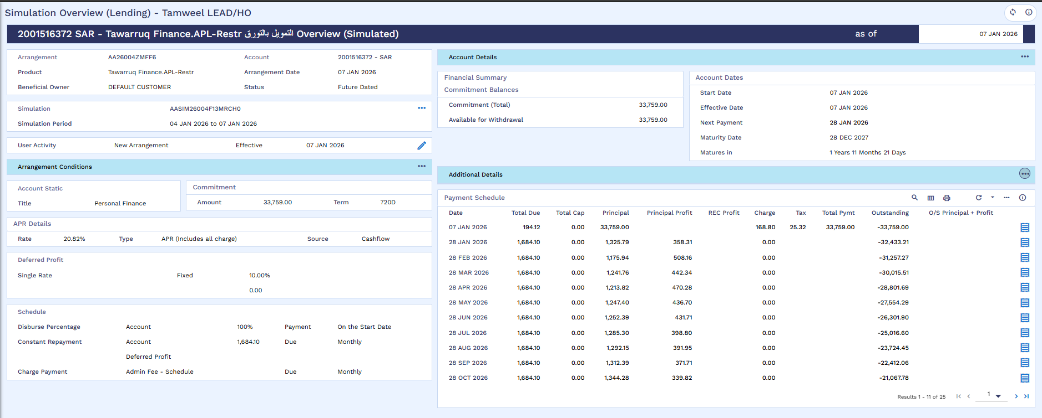
Simulation Generated in Transact

Financial Details
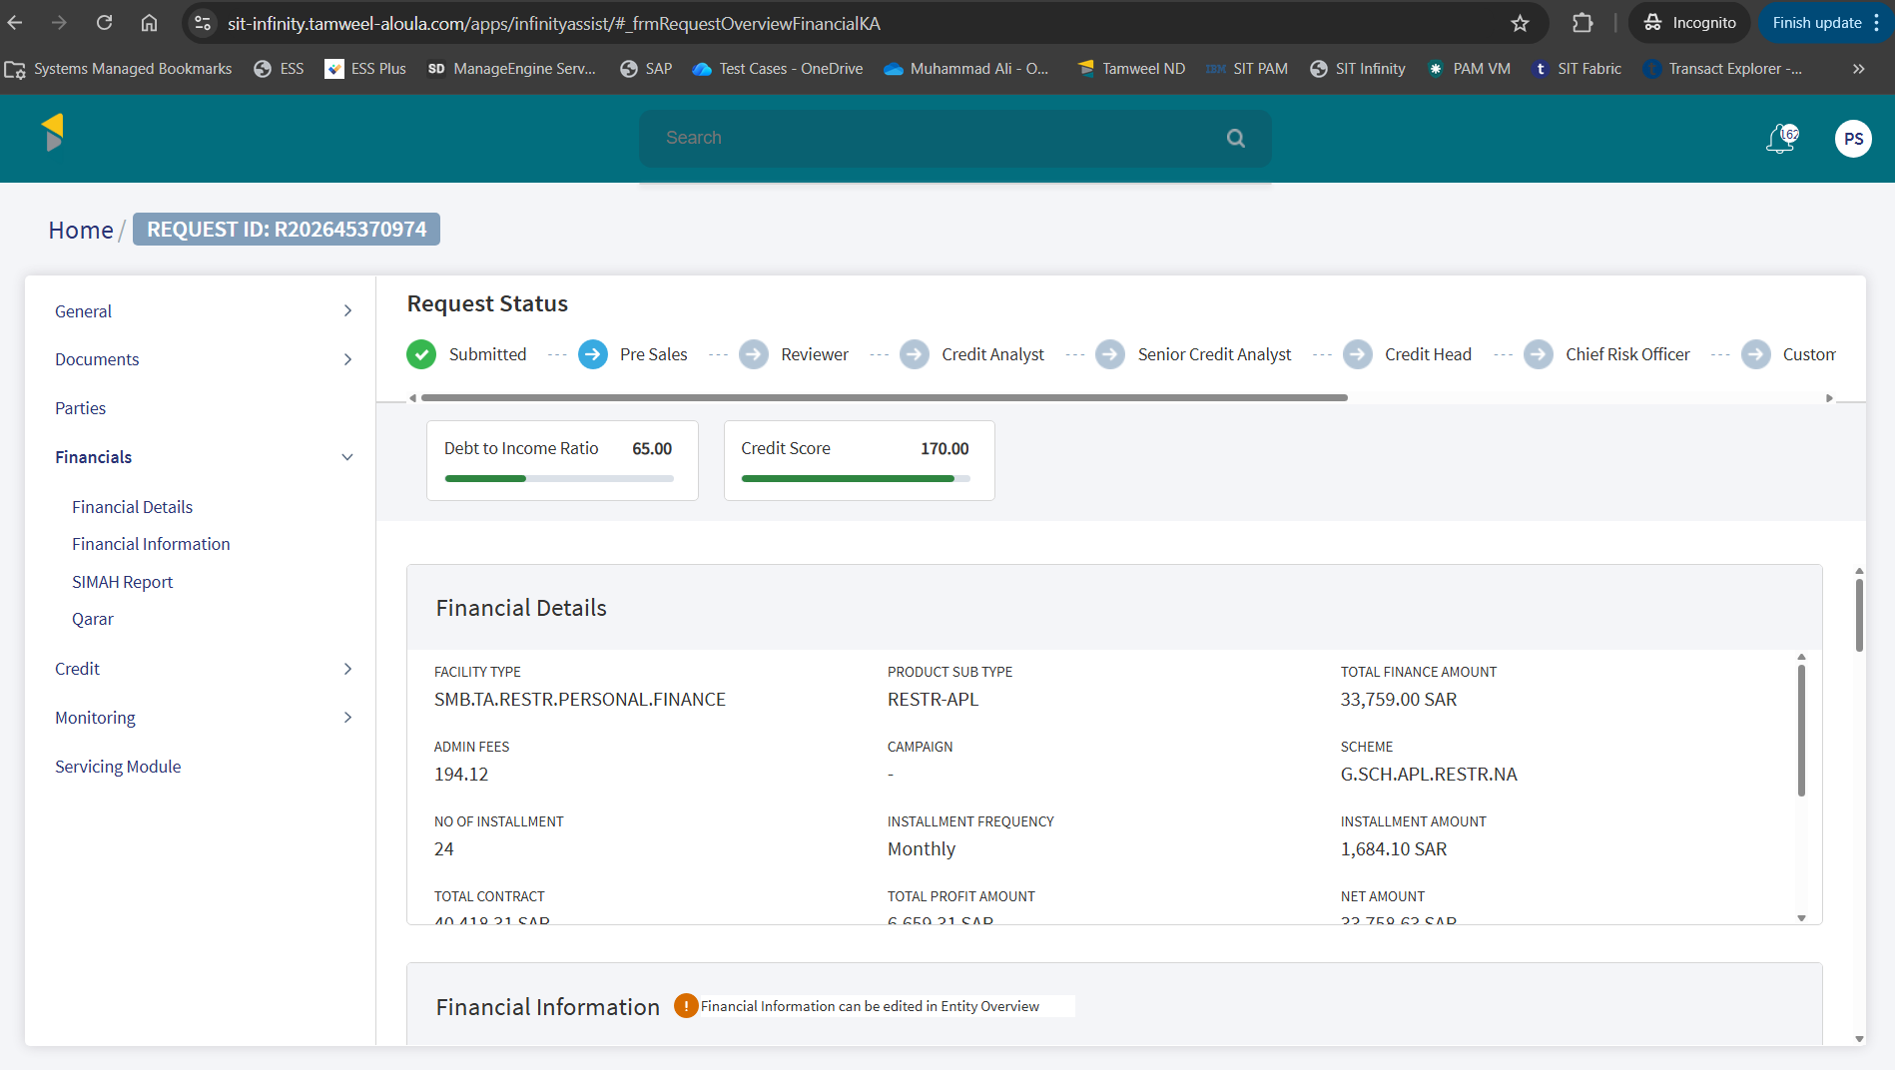
Financial Information

Simah Details
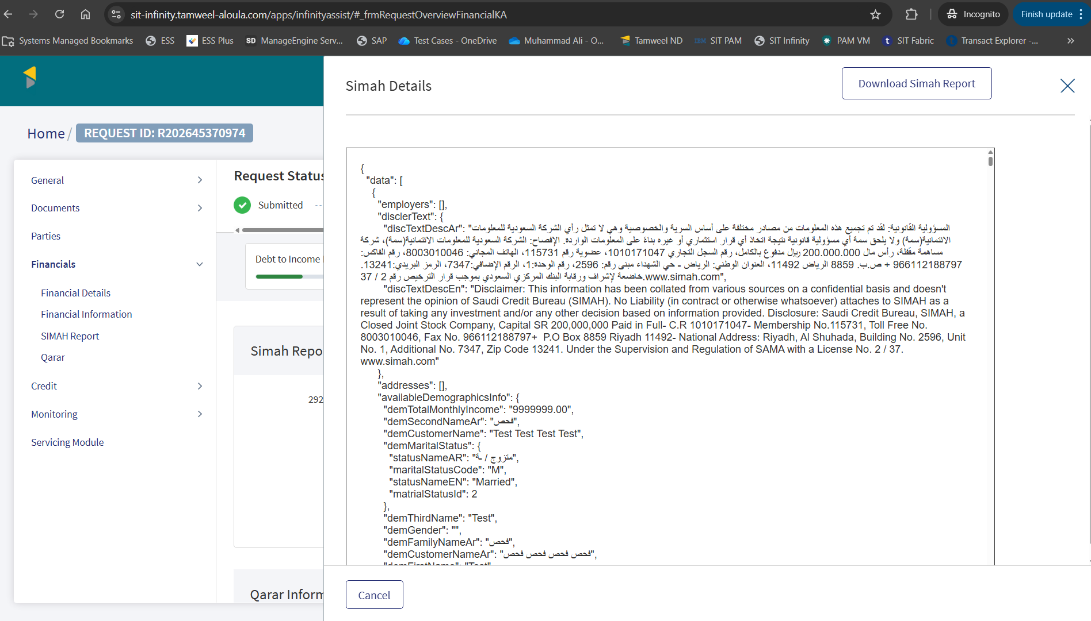
SIMAH Enquiry

Servicing Module
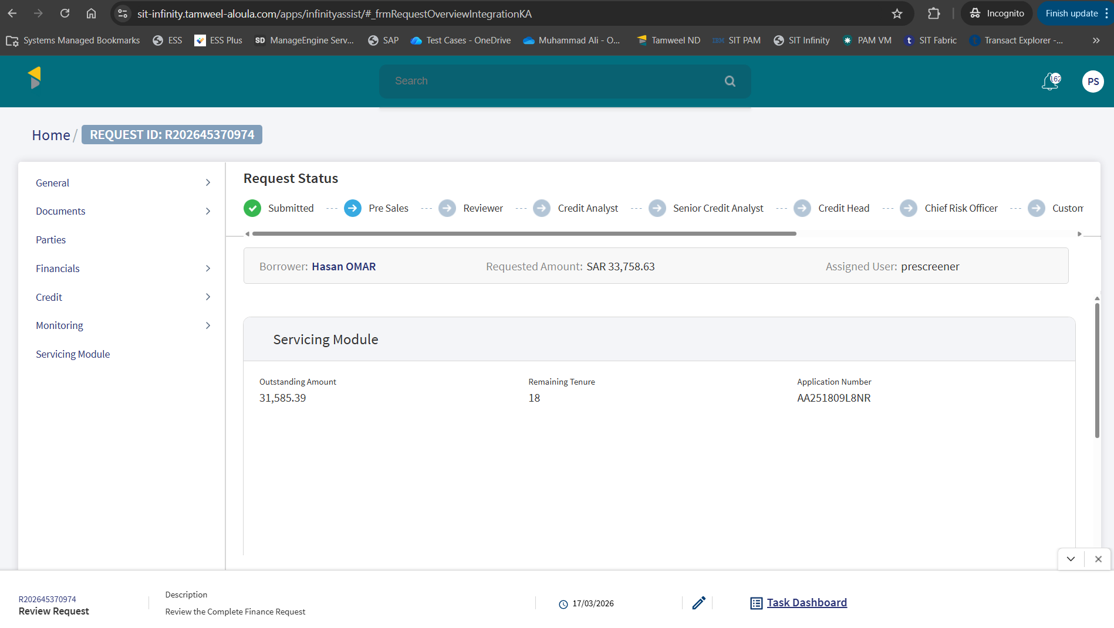
Servicing Module details
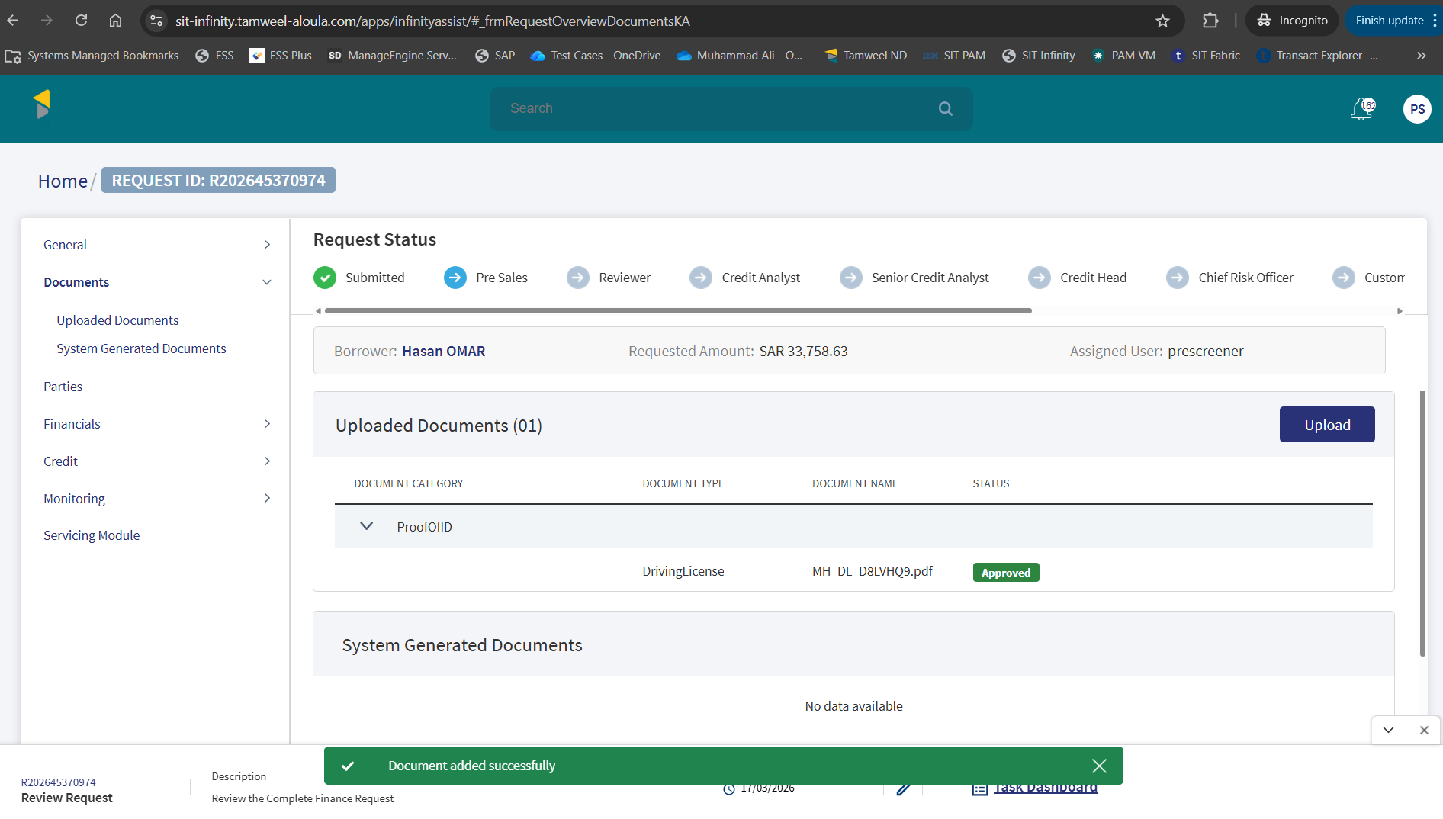
Document uploaded successfully

Application Approval
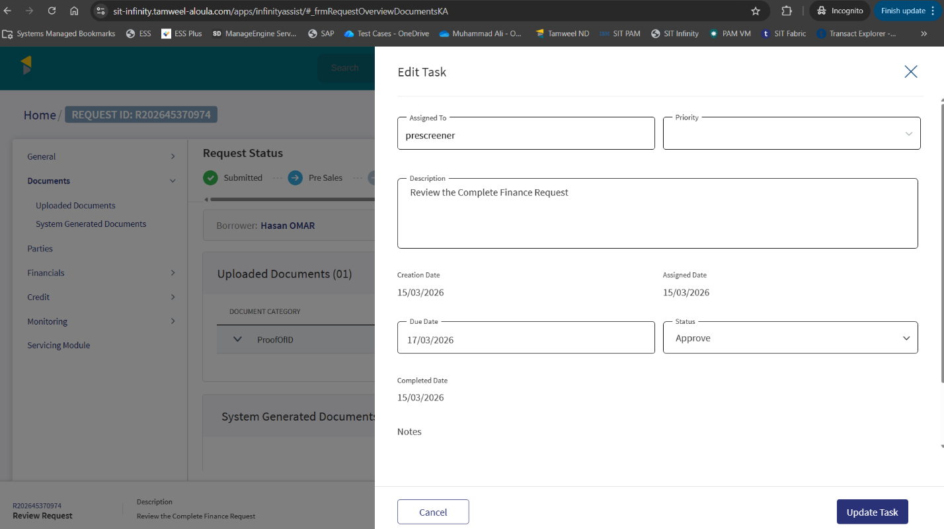
Application is approved from Presales
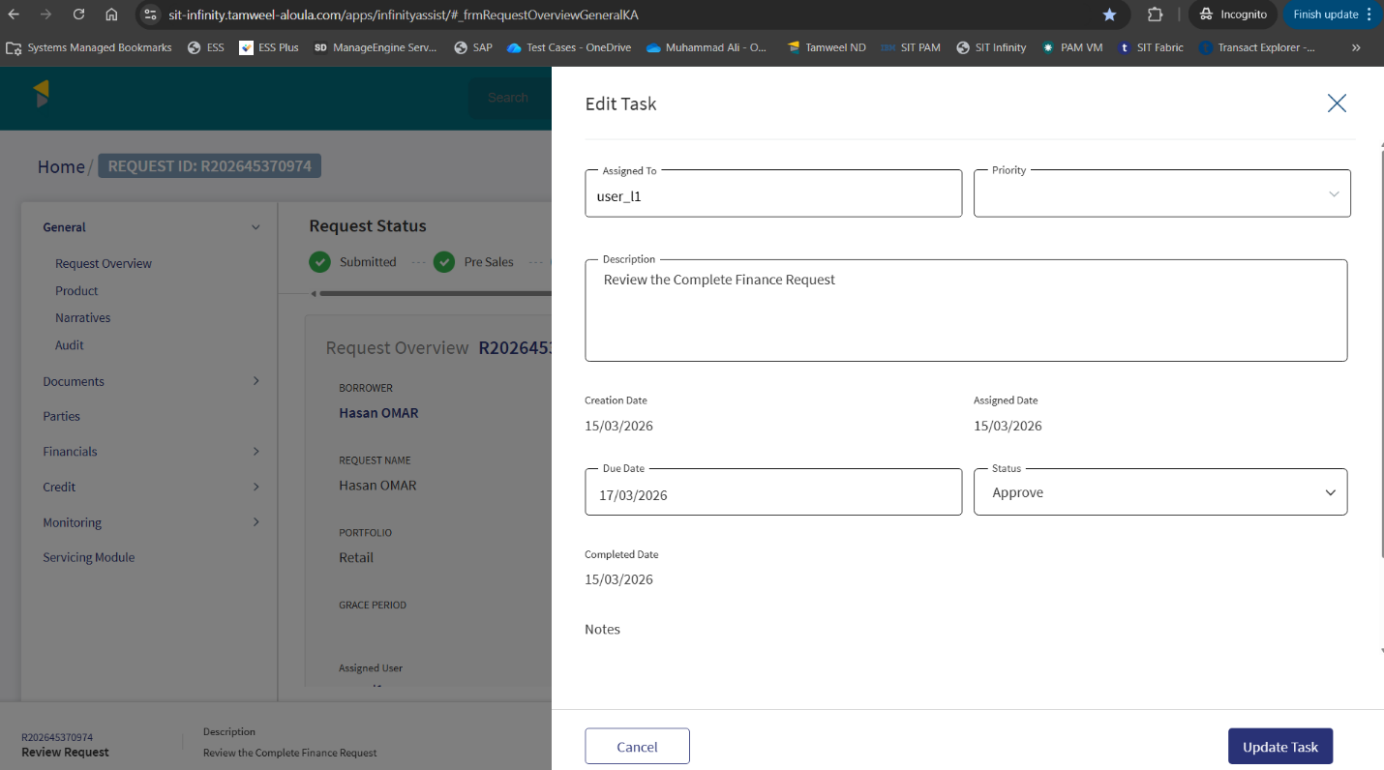
Application is approved from Reviewer
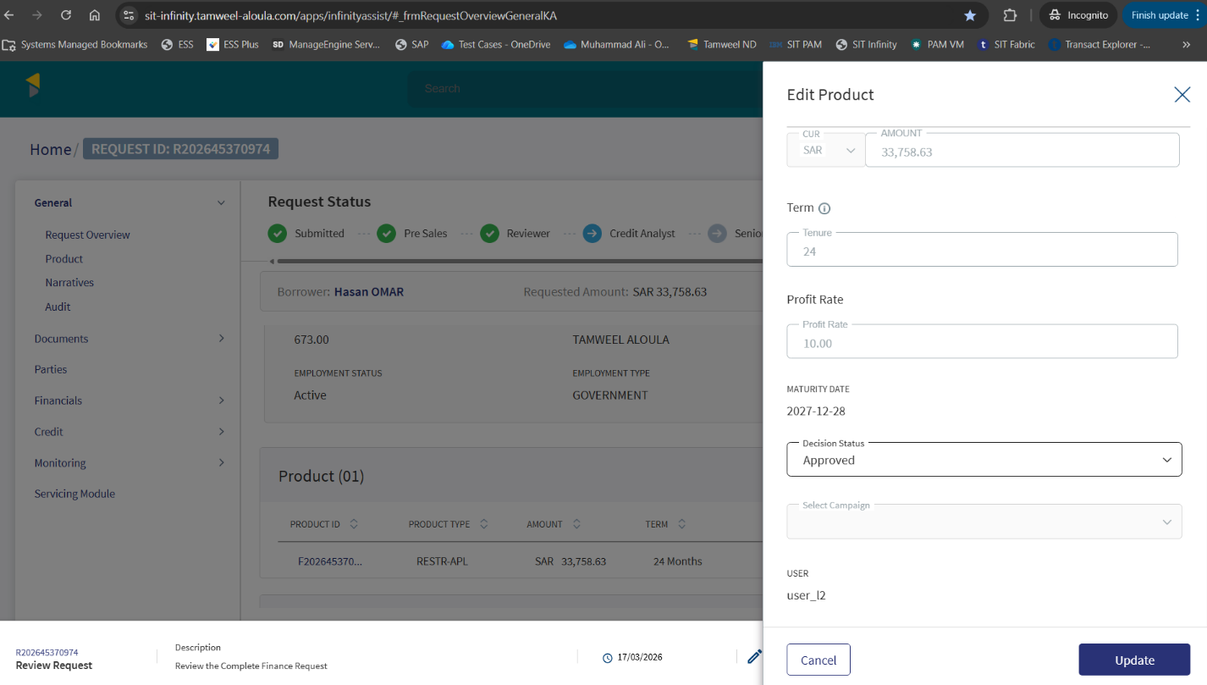
Loan amount is approved from Credit Analyst
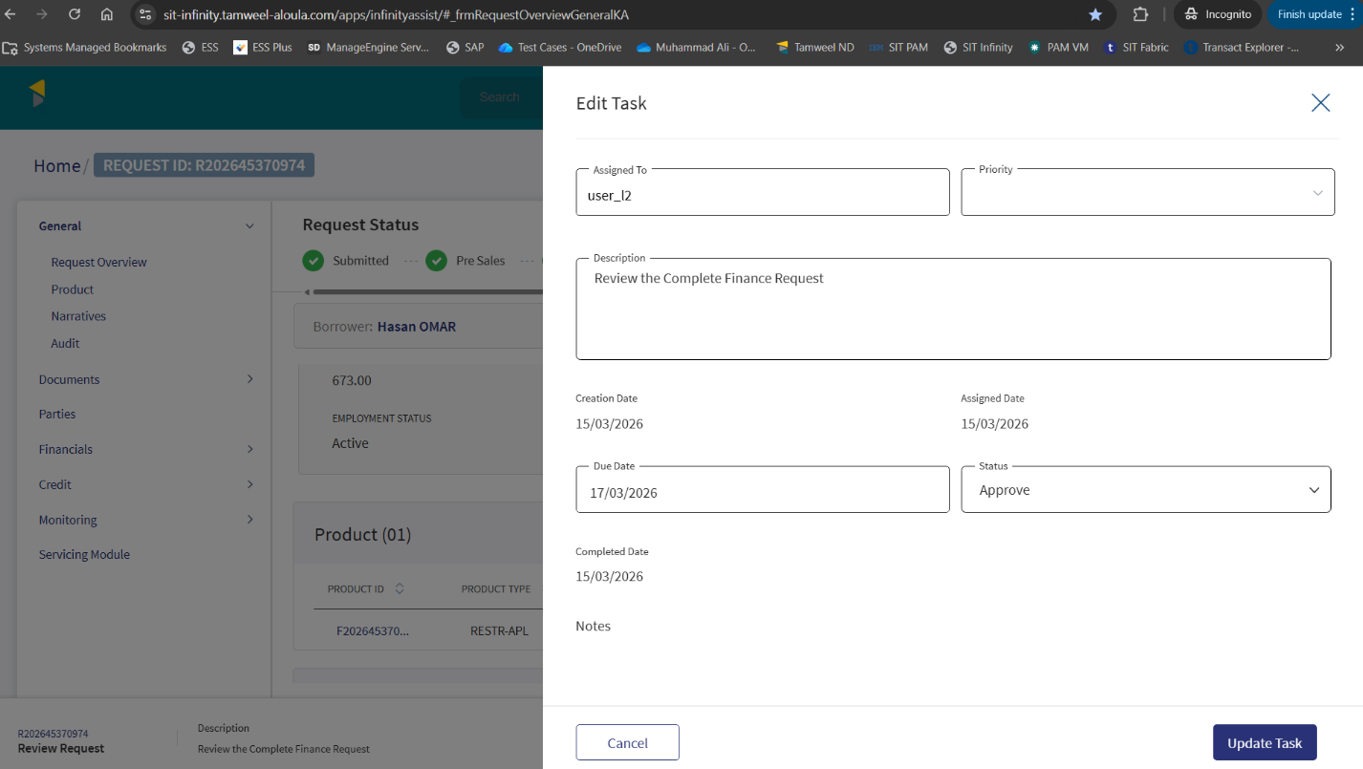
Application is approved from Credit Analyst

Offer Generation
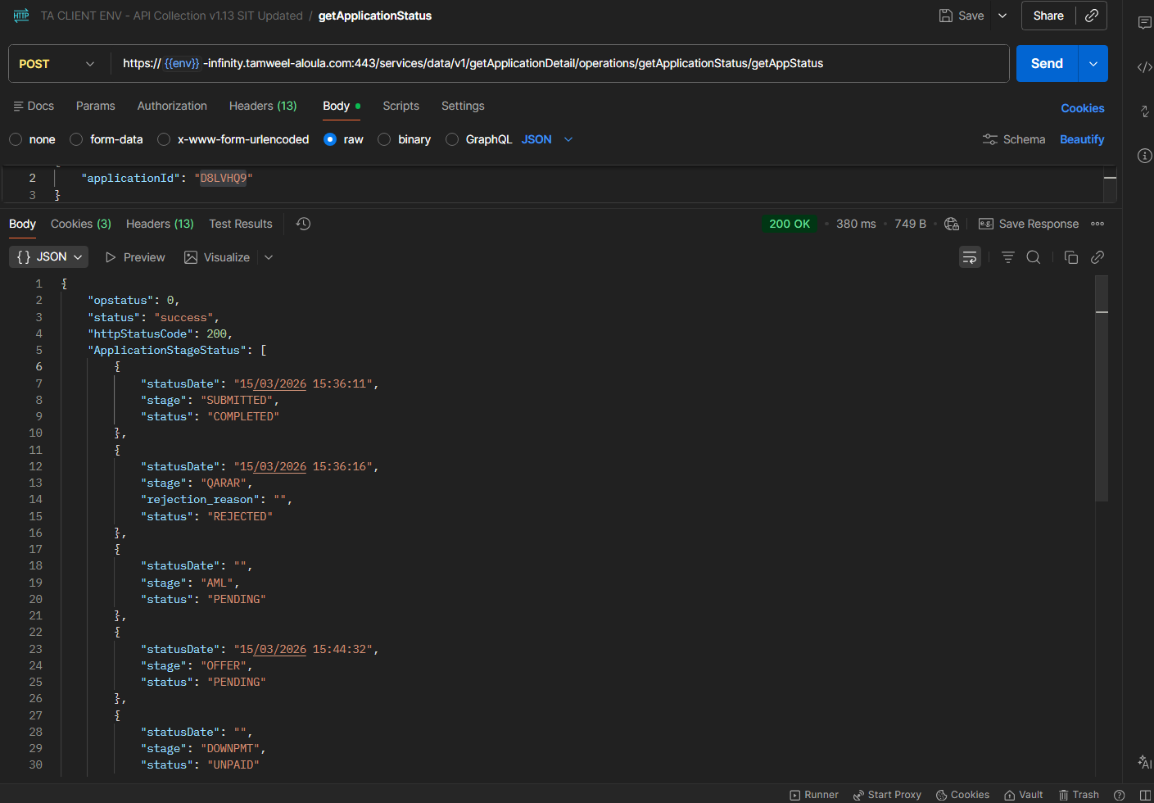
Offer is generated

Offer Acceptance
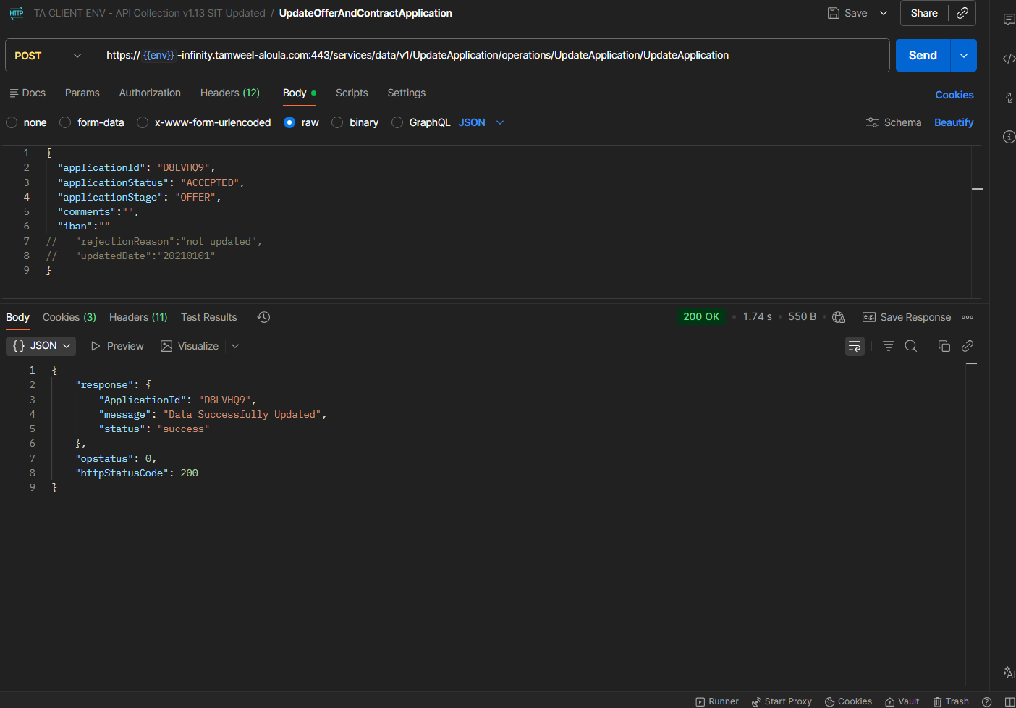
Offer is accepted

Application Details in Transact
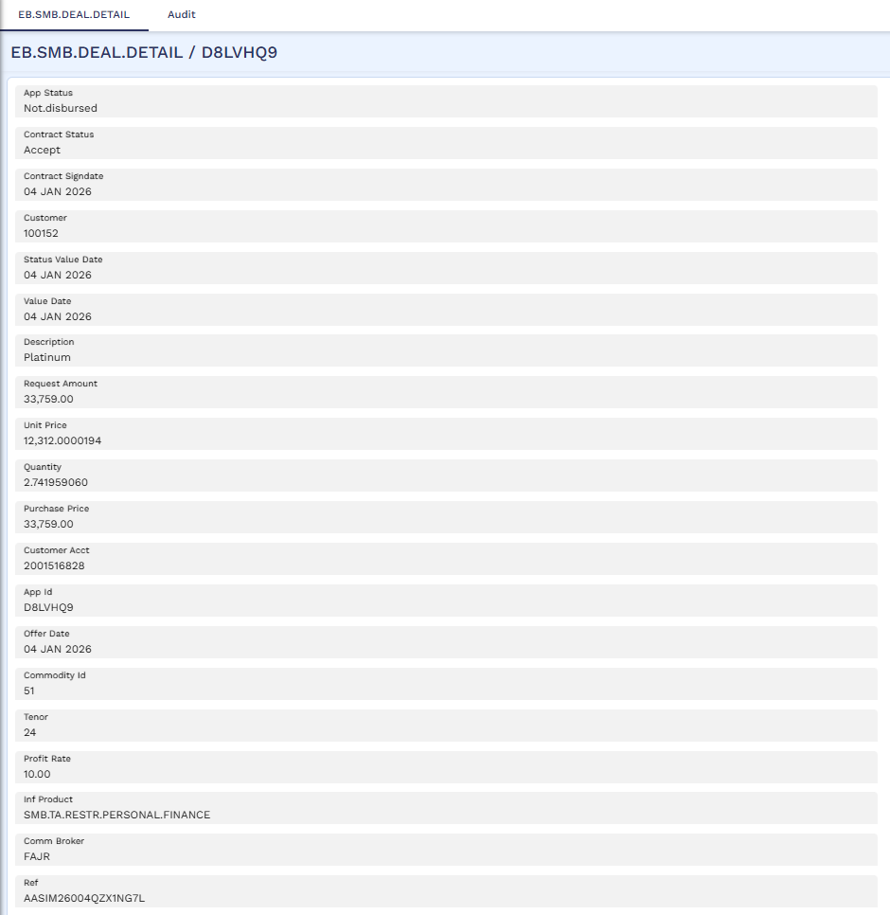
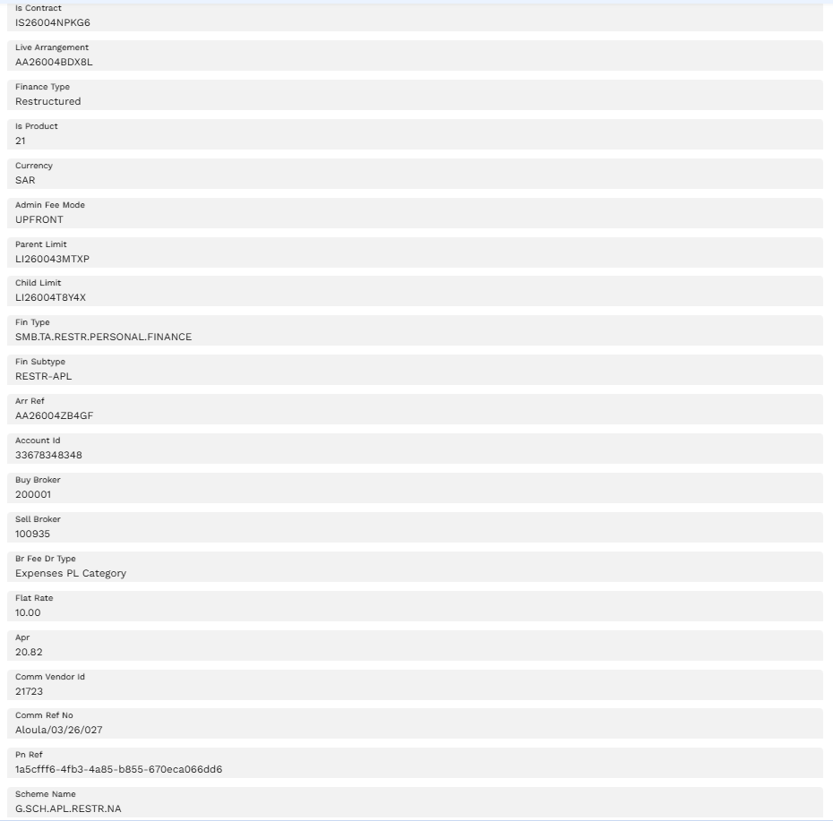
Application landed on Transact

STP Process
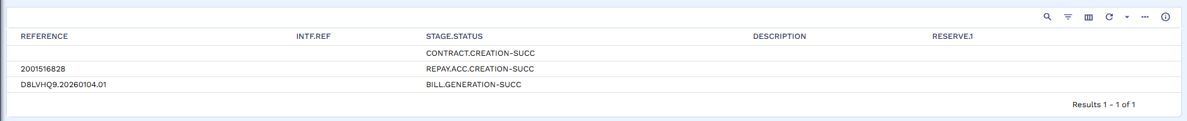
STP process Started

Bill Generation
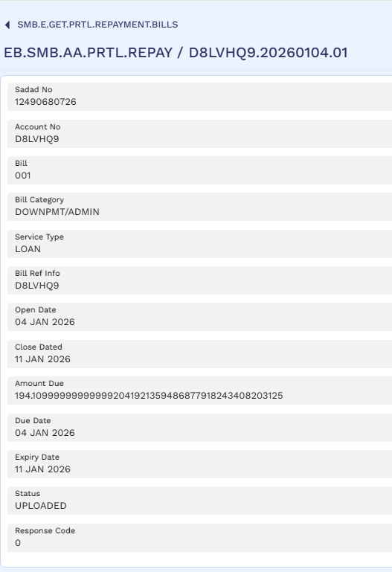
Admin fee bill generated

Bill Payment
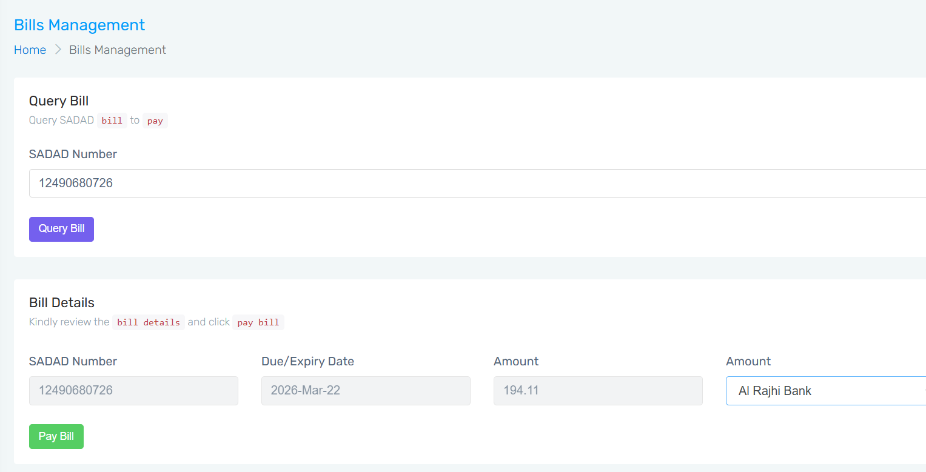
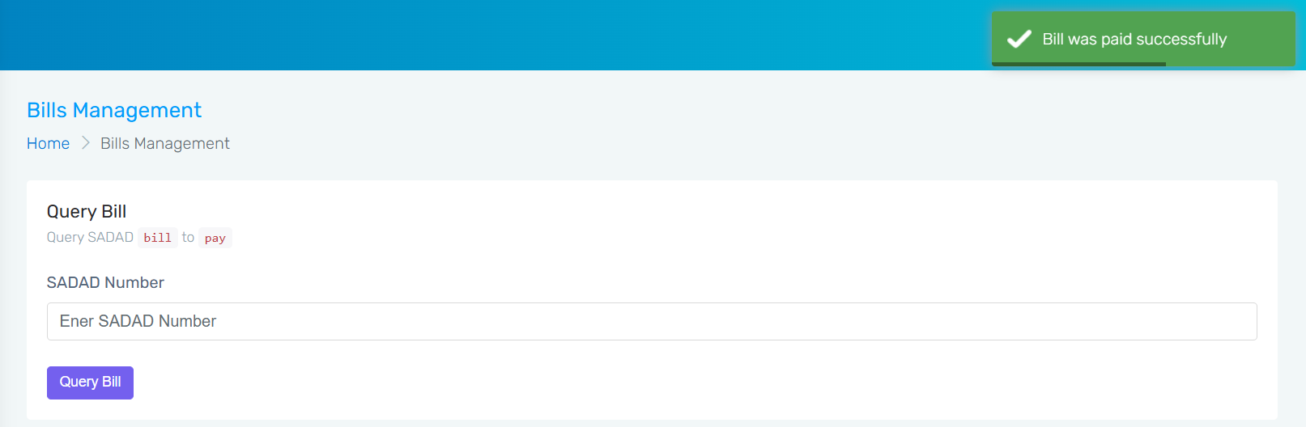
Bill Paid through Rosom

Contract
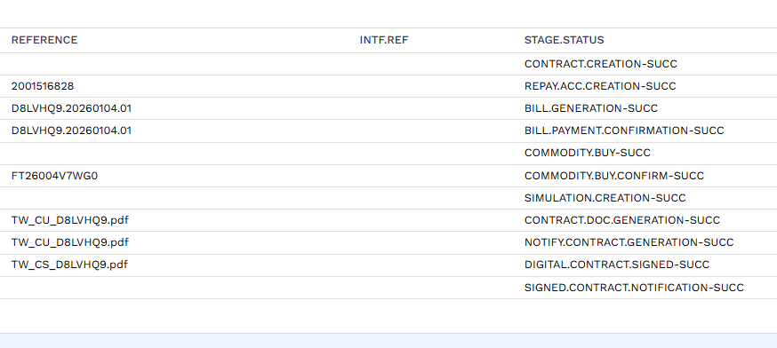
Contract Generated

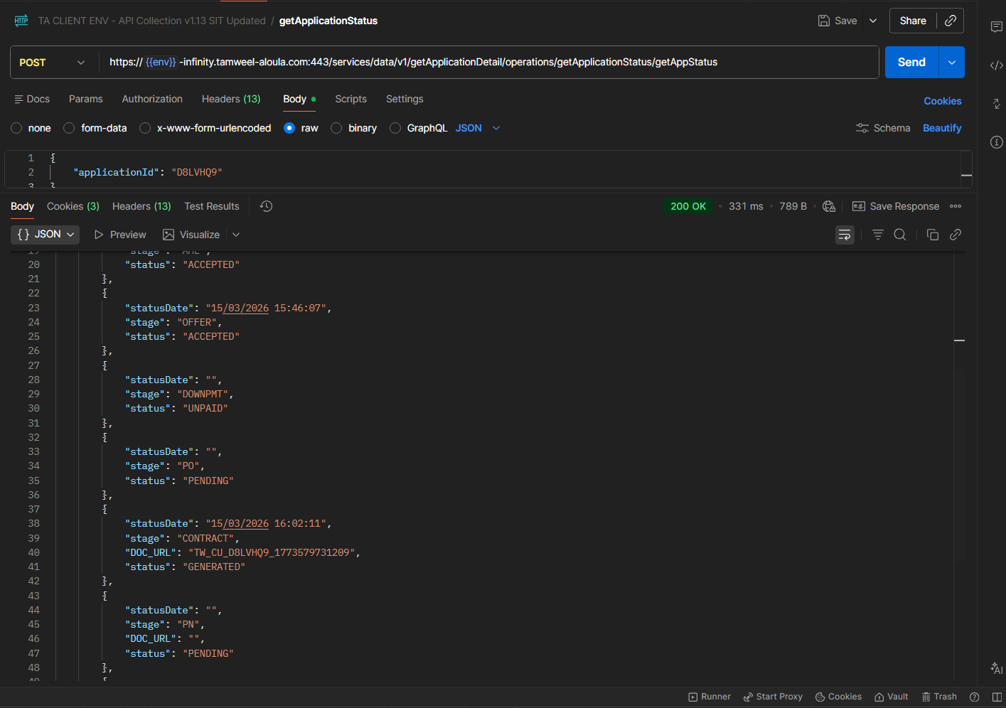
Status is updated against Offer and AML. Status updated for Contract stage as “GENERATED”

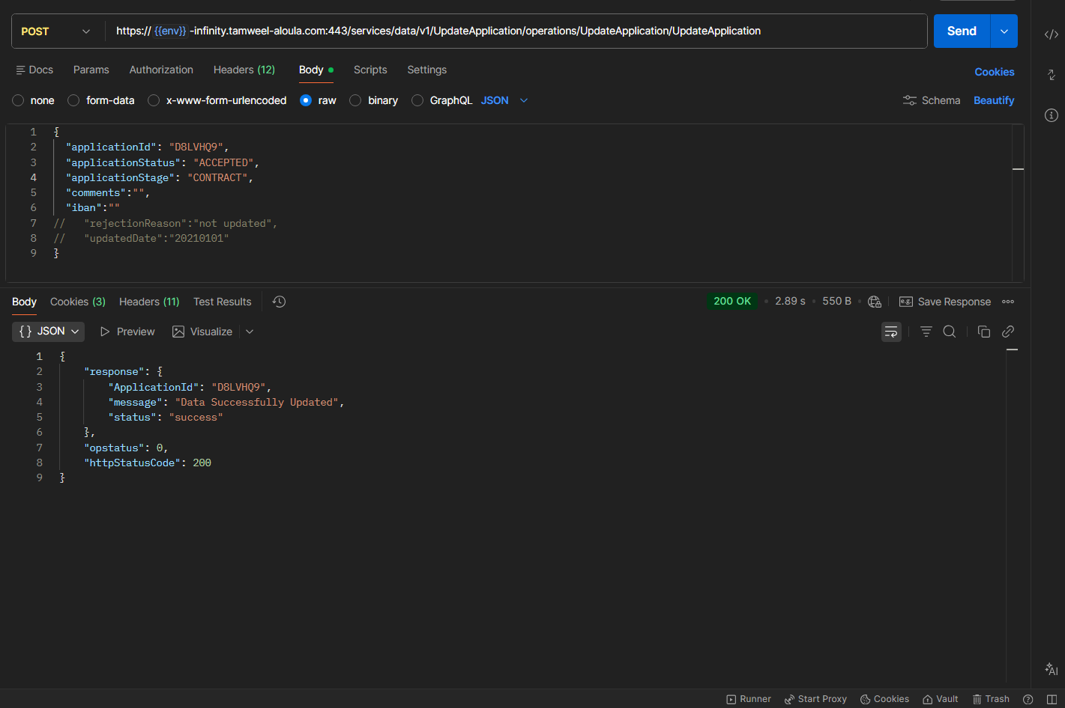
Contract is accepted using API
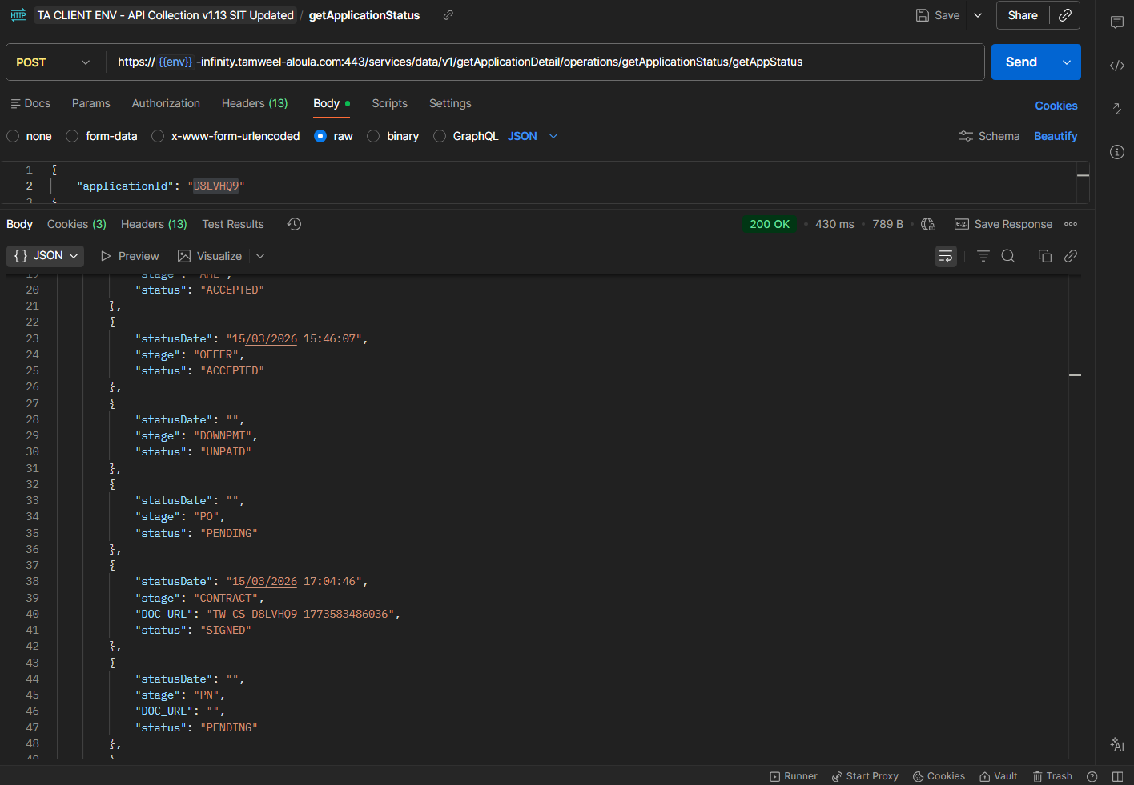
Status is updated as “SIGNED”

Promissory Note
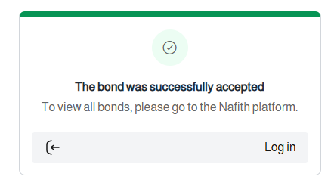
PN accepted

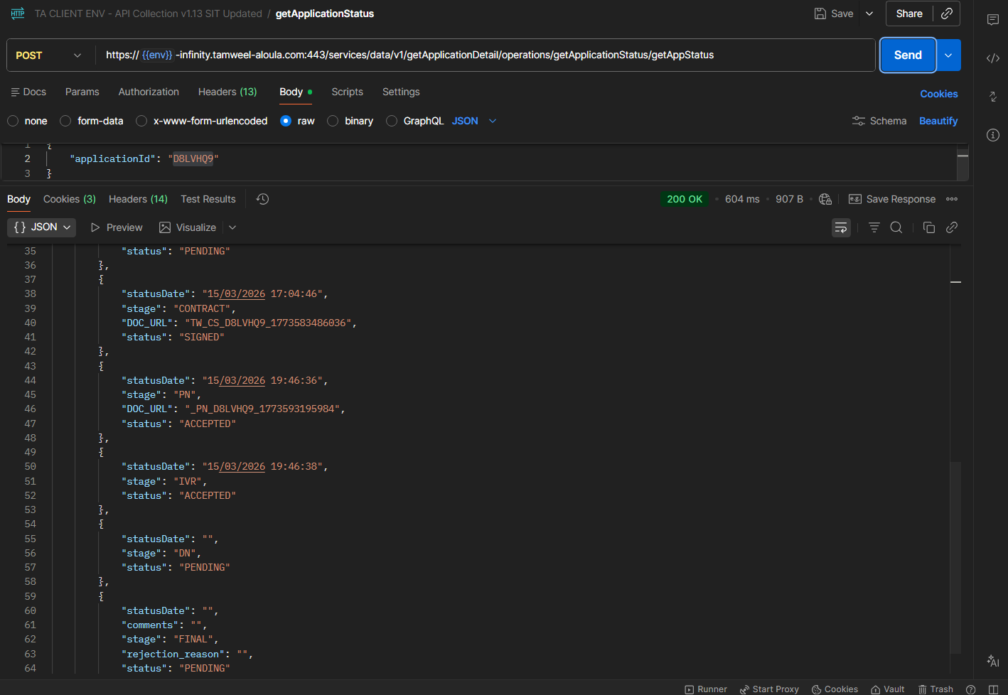
PN and IVR accepted along with status updating

STP Complete
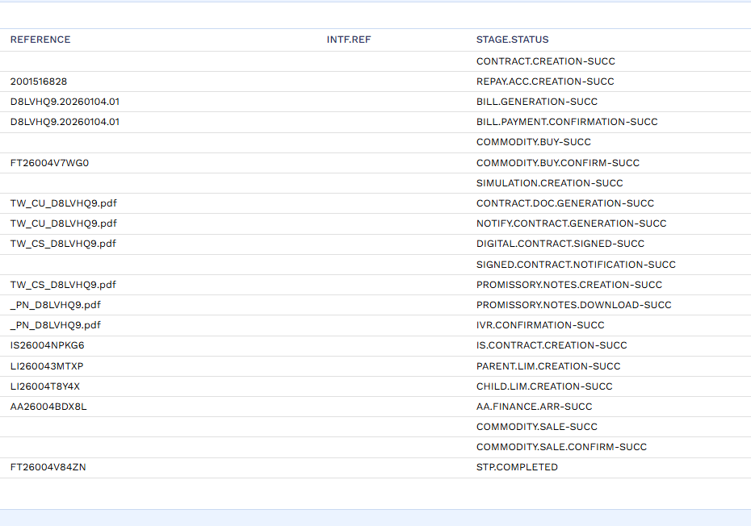
STP Completed

New Arrangement
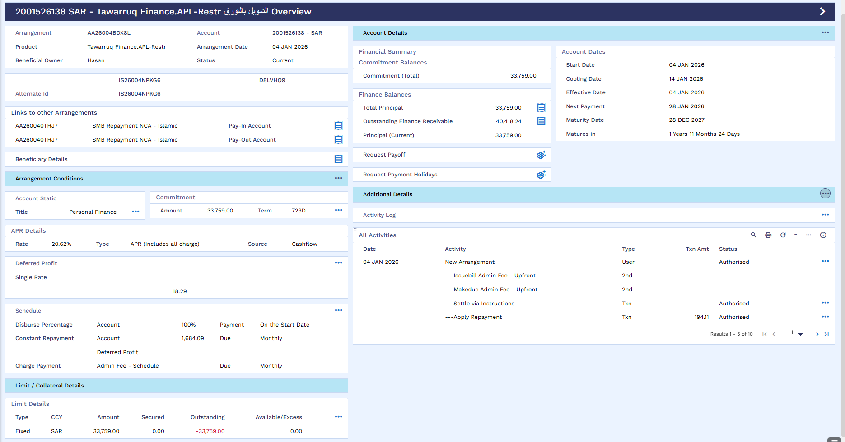
New AA arrangement created

New Arrangement Accounting Entries
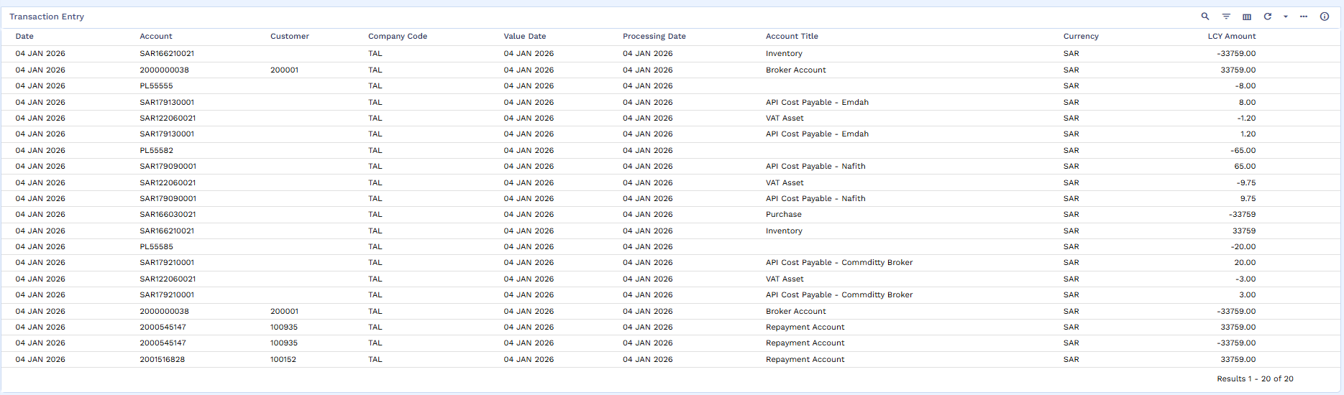
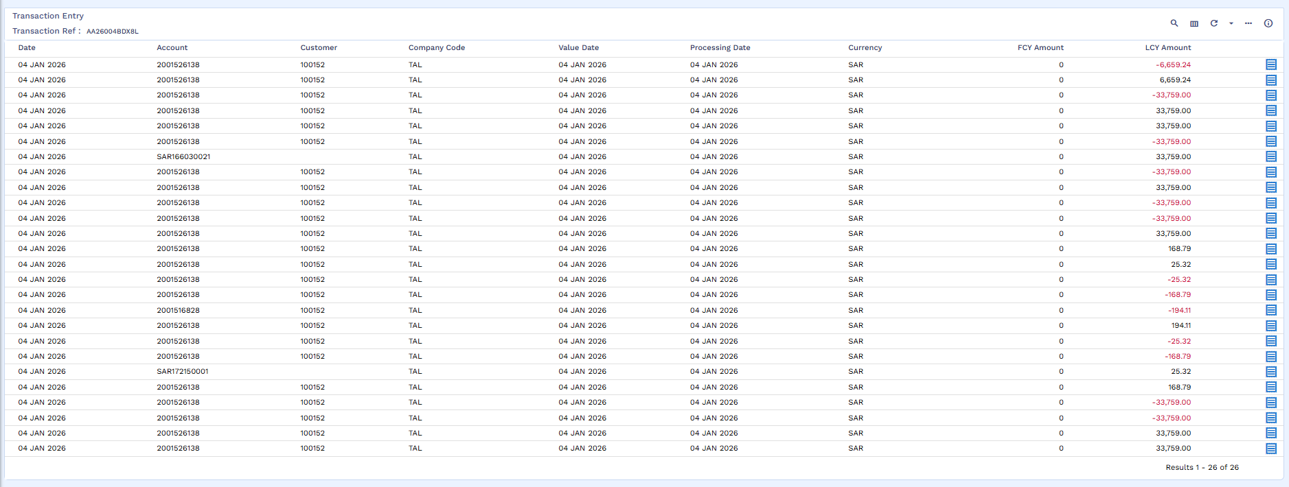
Accounting Entries
New Arrangement’s Repayment Account
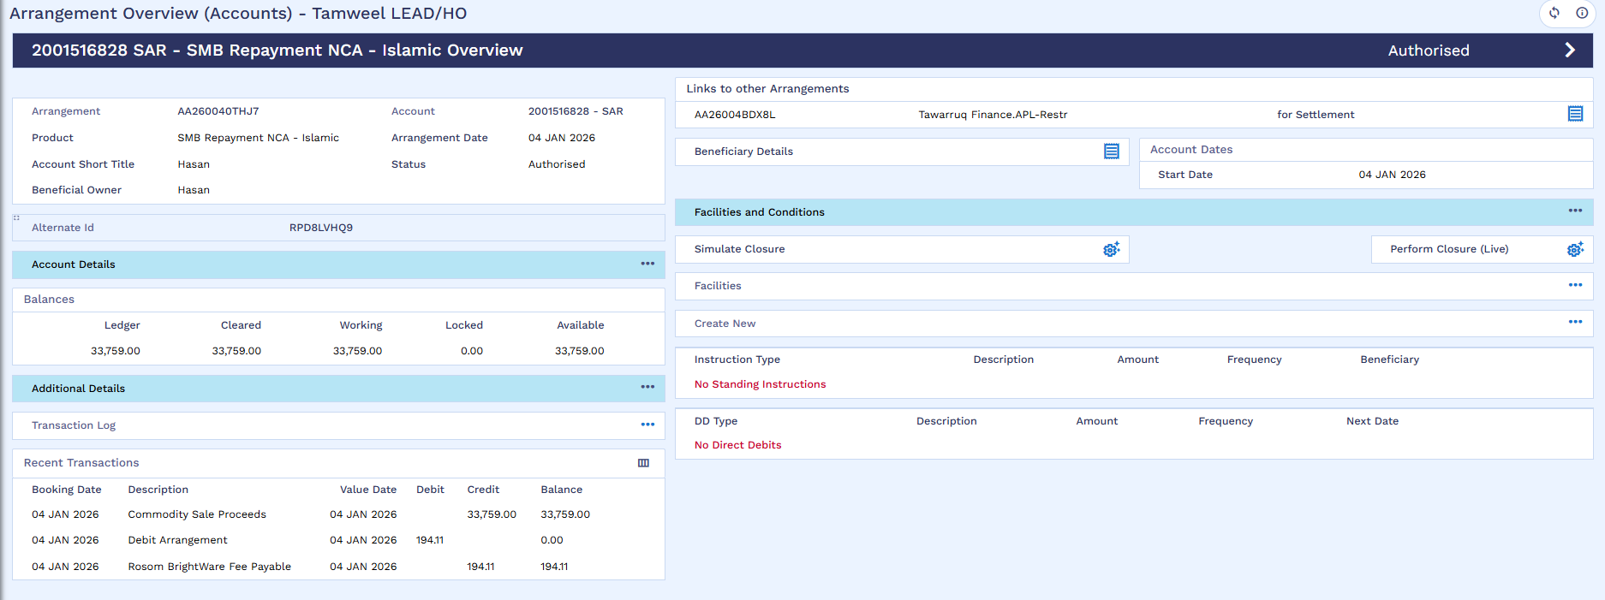
Funds available in AA repayment account

Disbursement
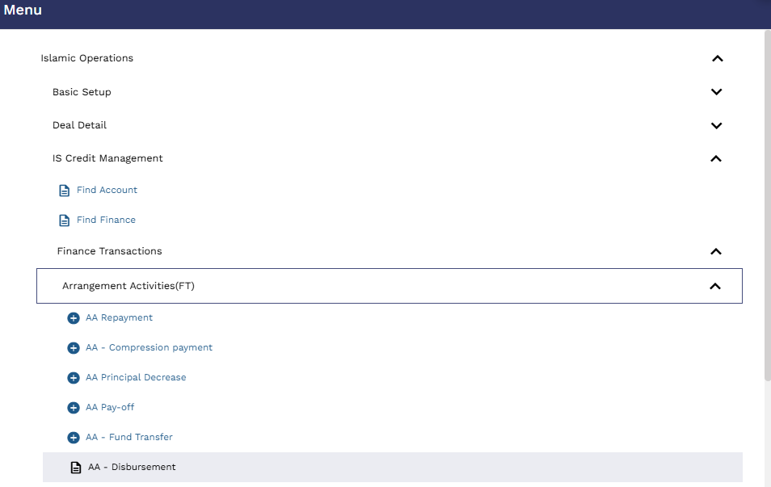
User will go to ?16 AA disbursement
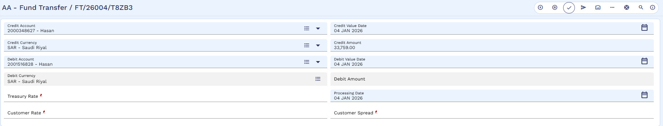
user need to put Credit account which is the old arrangement repayment account and debit the new Restructure repayment account to make the funds available in order to settlement old arrangement.
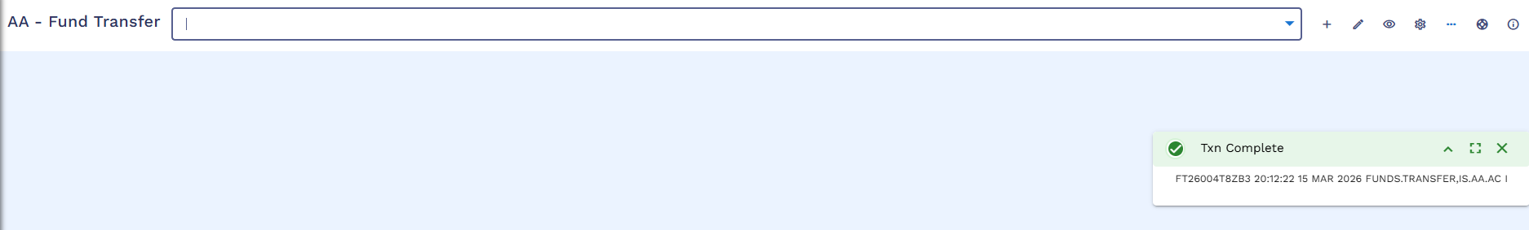
User will commit the record.
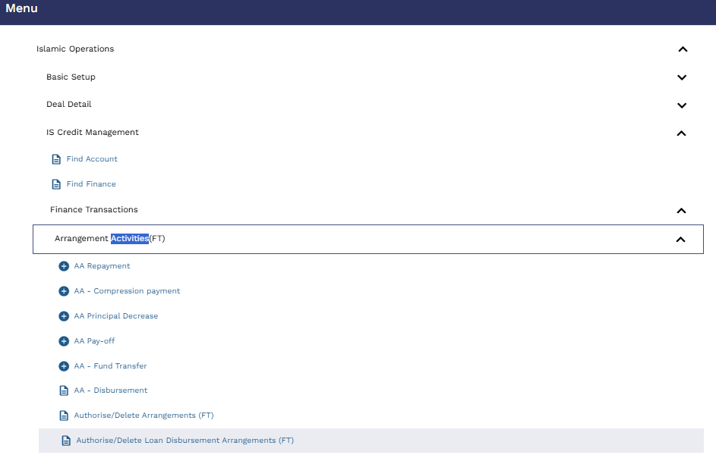
Authorizer will go to ?16 and Authorize / Delete Arrangement (FT)
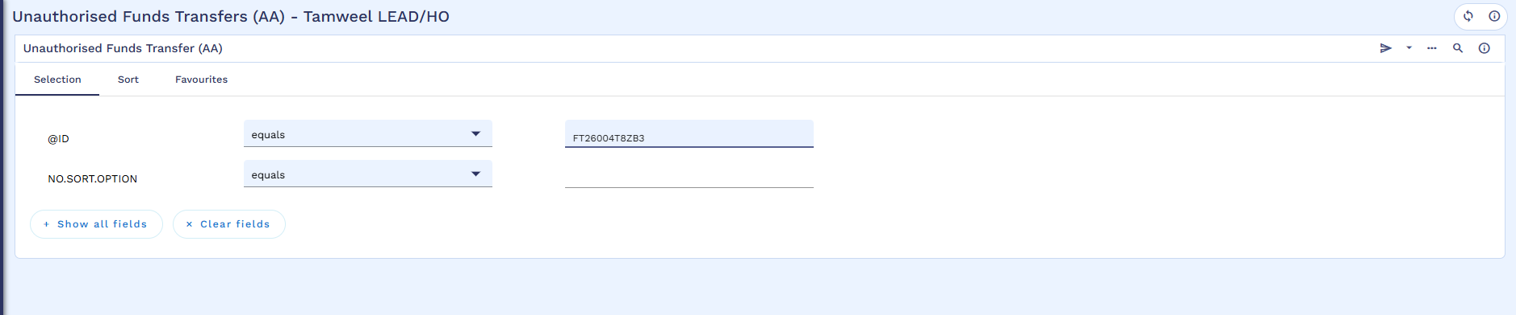
Authorizer will search the FT
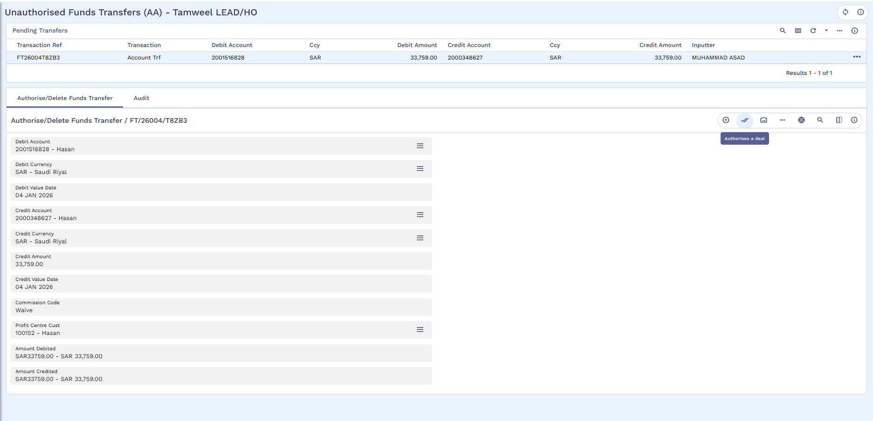
Authorizer will review the records
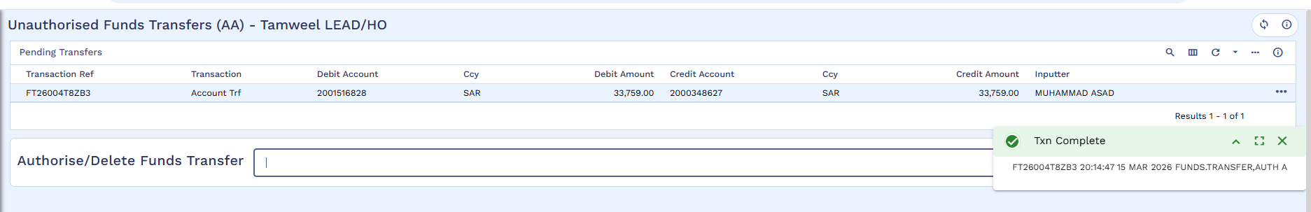
Commit the transaction

Payoff of Old Arrangement
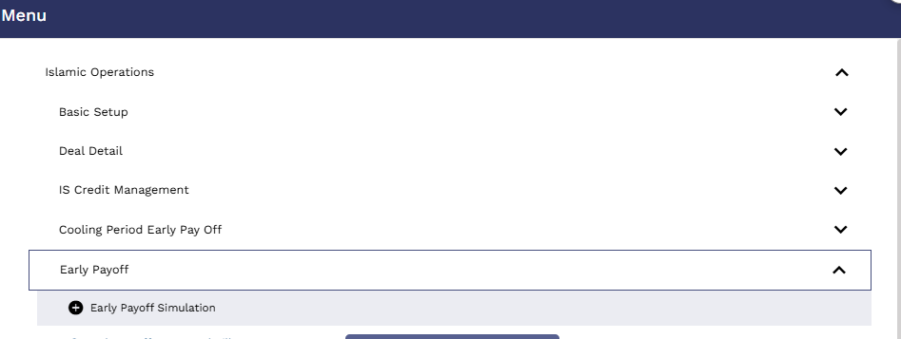
User will run old arrangement early payoff simulation
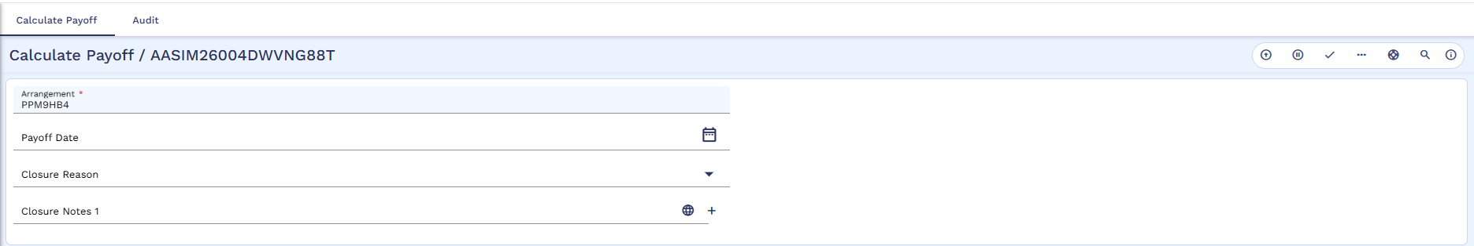
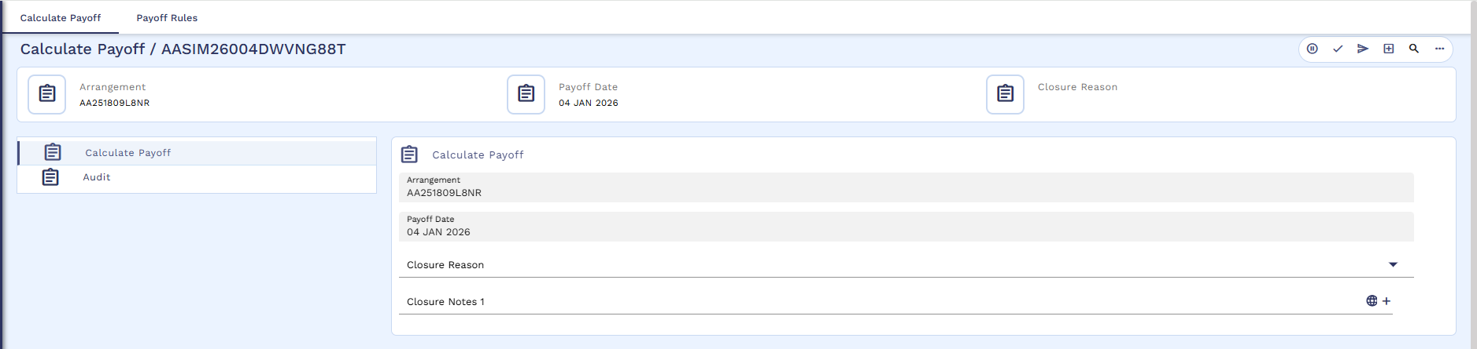
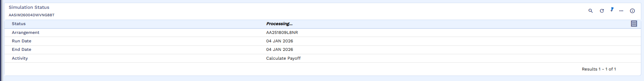
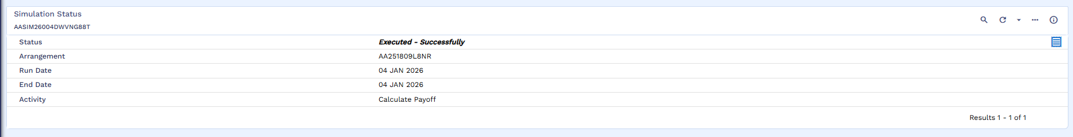
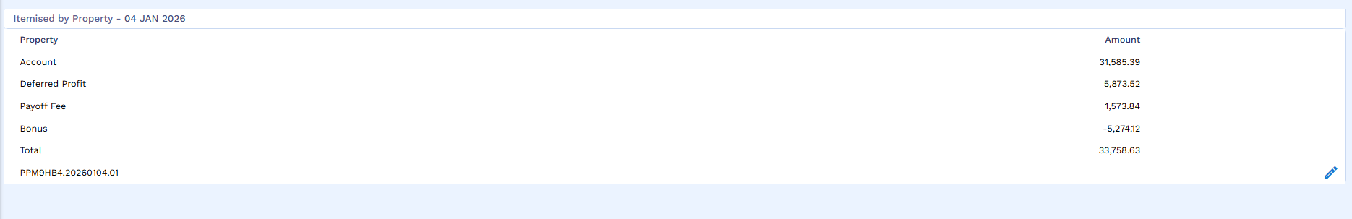
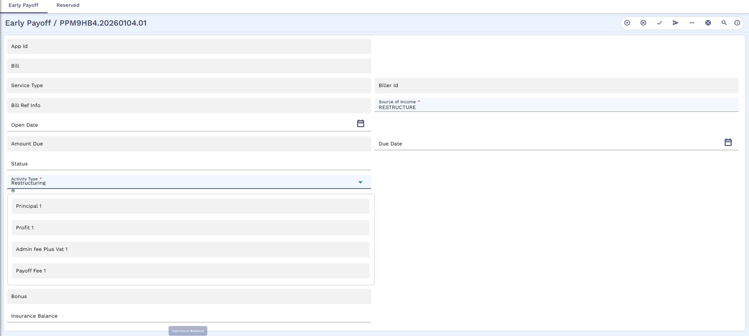

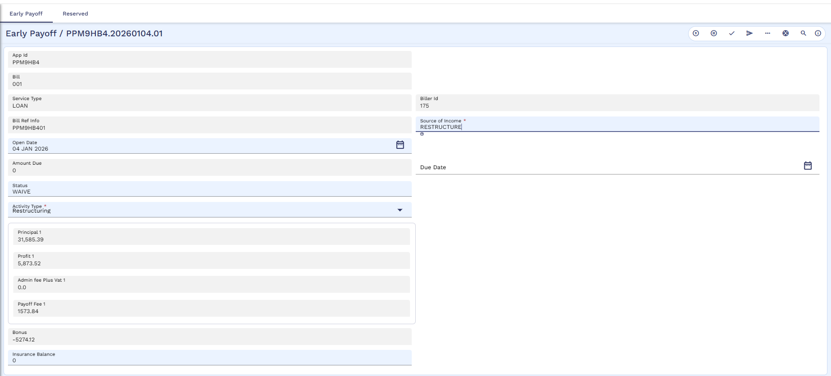
User will generate bill
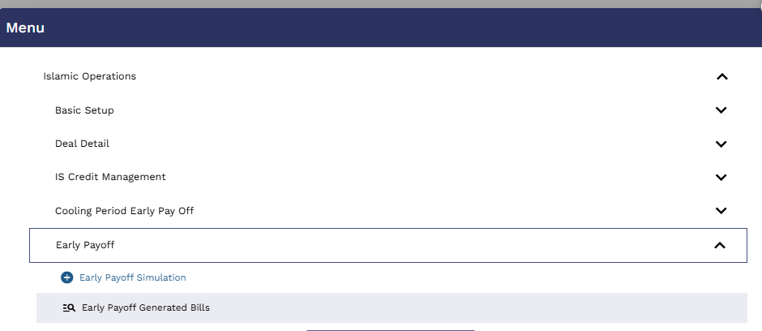
User will check the generated bill
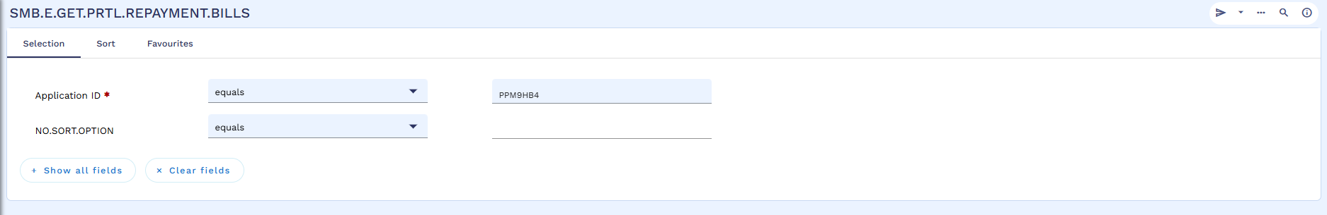
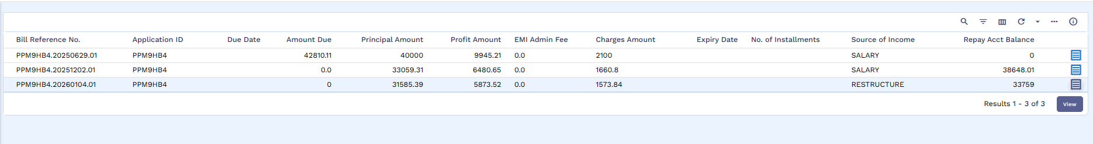
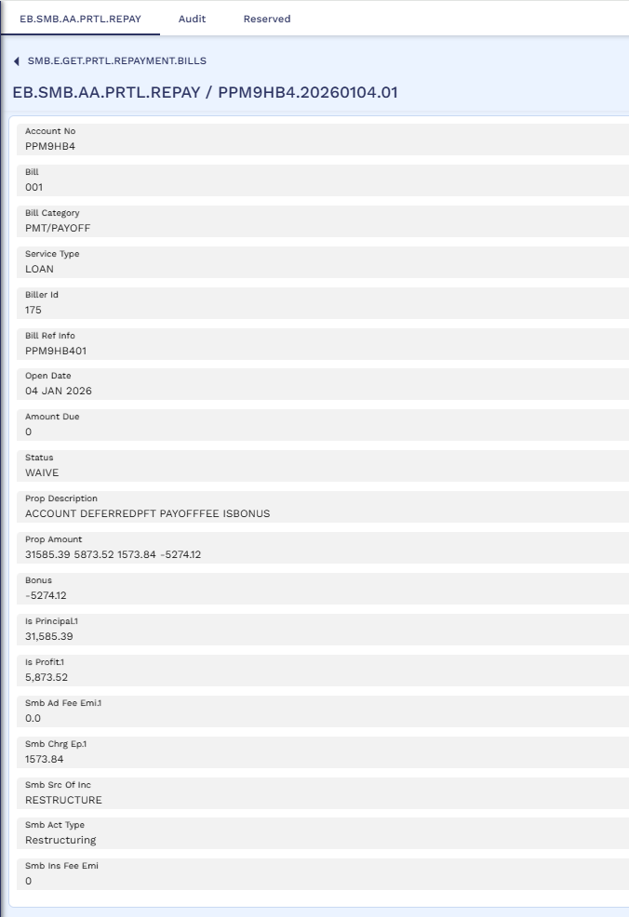
Please note that the due amount is Zero as the funds are already available as the Funds are transferred from Restructured Loan Repayment account to Old arrangement repayment account.
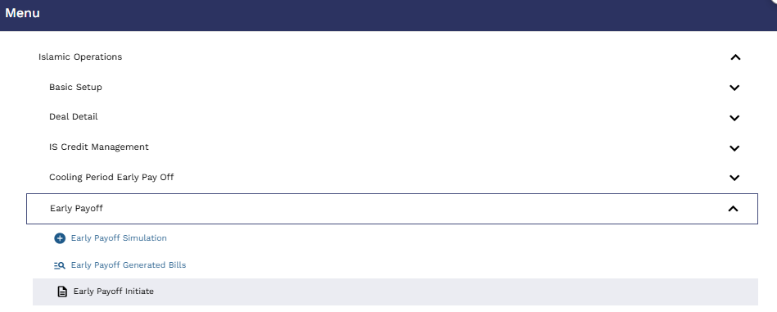
User will initiated the early payoff
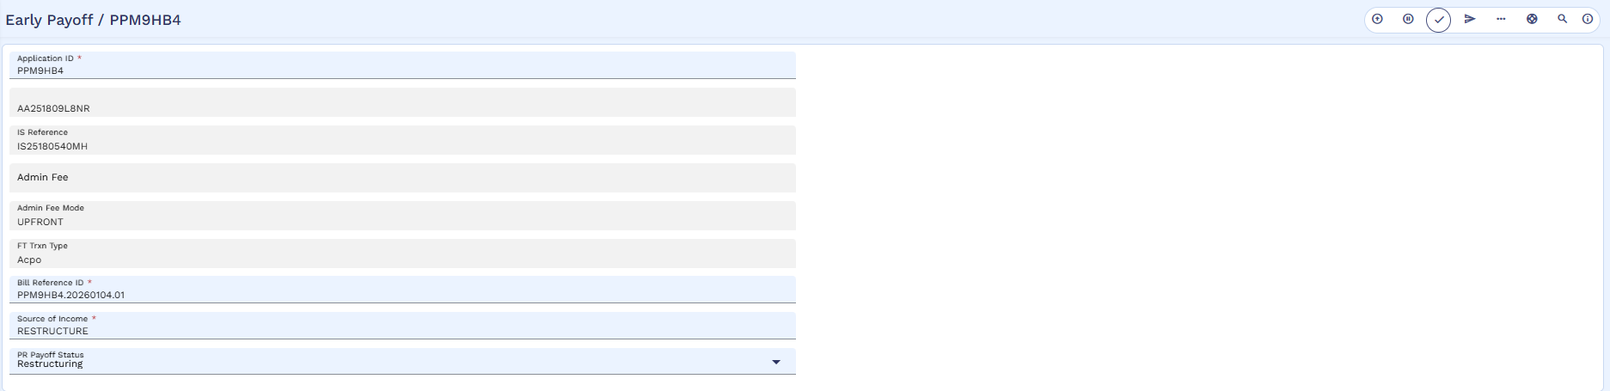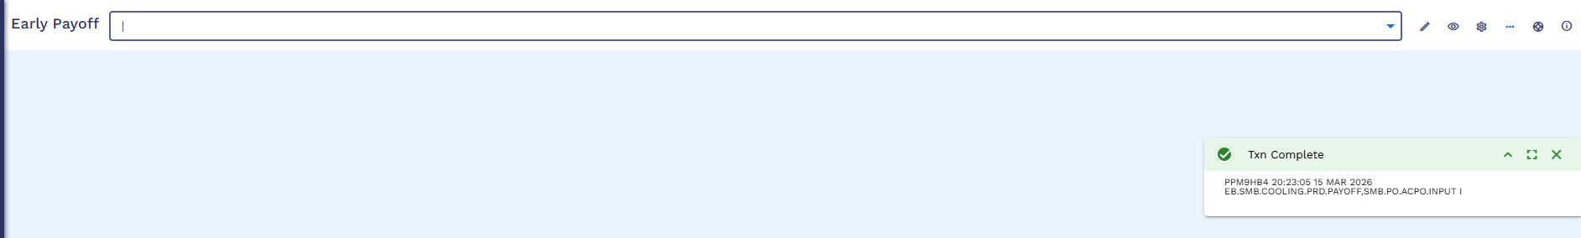
Commit the record
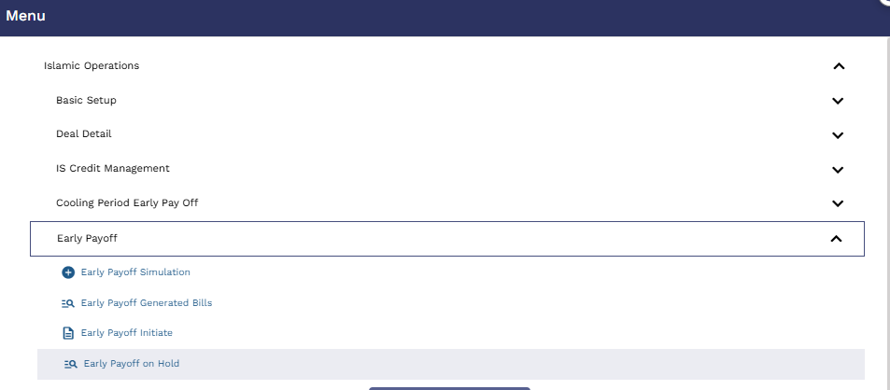
User will go to in HOLD
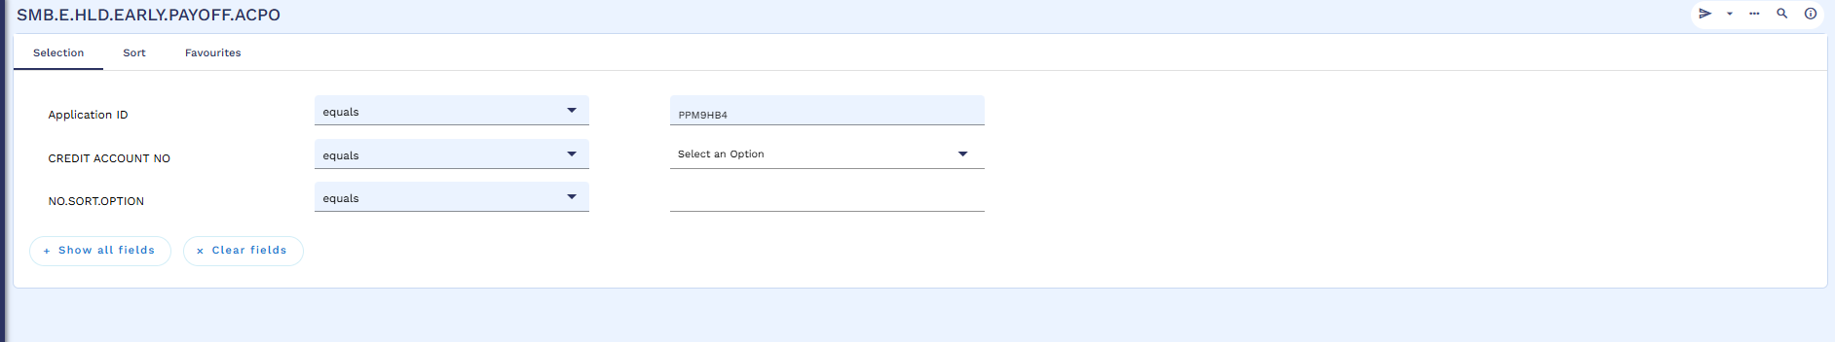
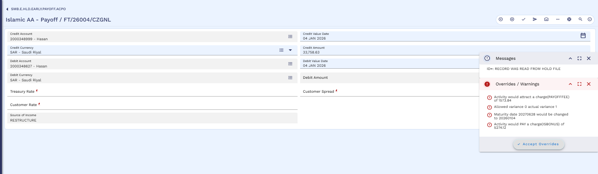
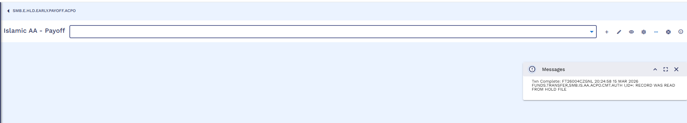
User will commit the record.
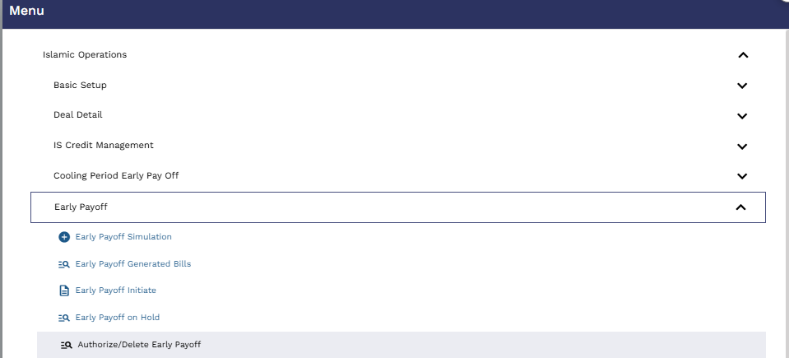
Authorizer will go to ?16
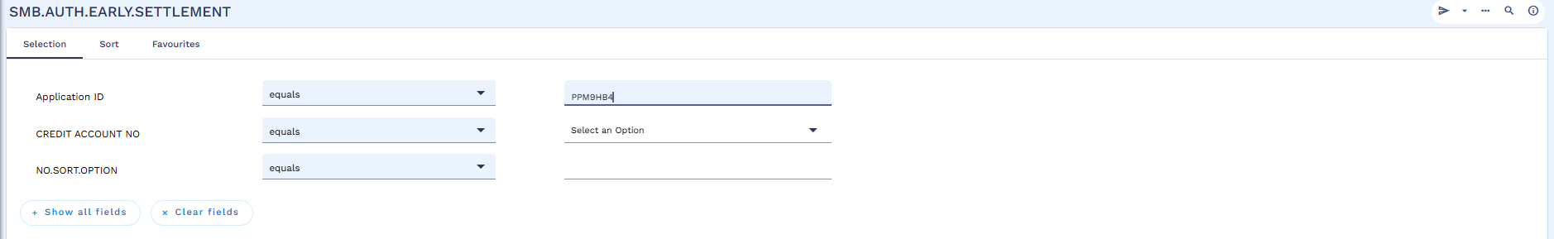
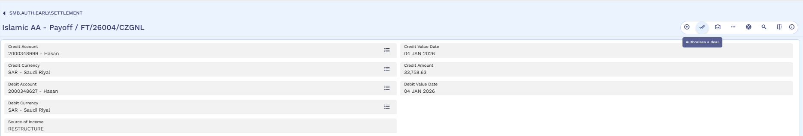
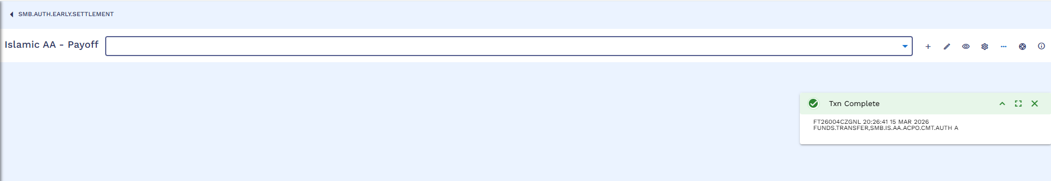
Authorizer will authorize the record

Closure of Old Arrangement with Accounting entries
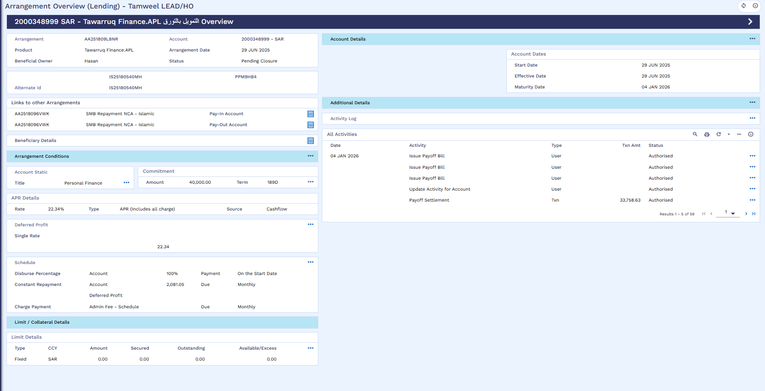
OLD arrangement status is changed to “Pending Closure”
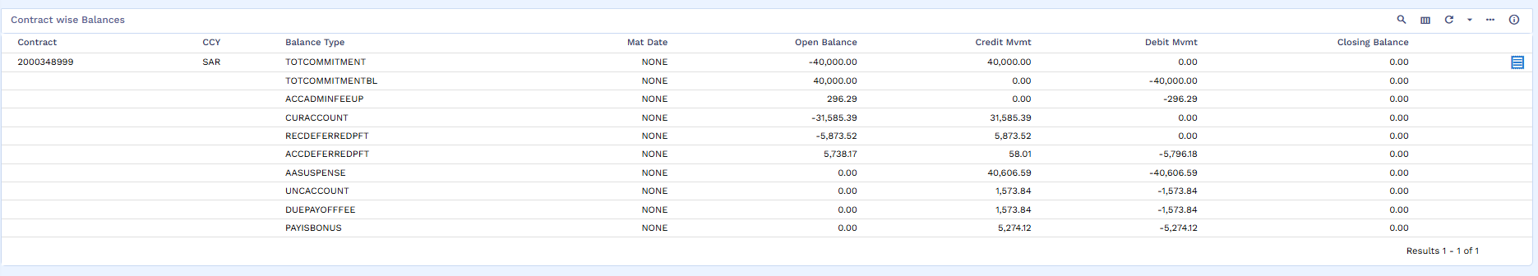
All balances are Zero
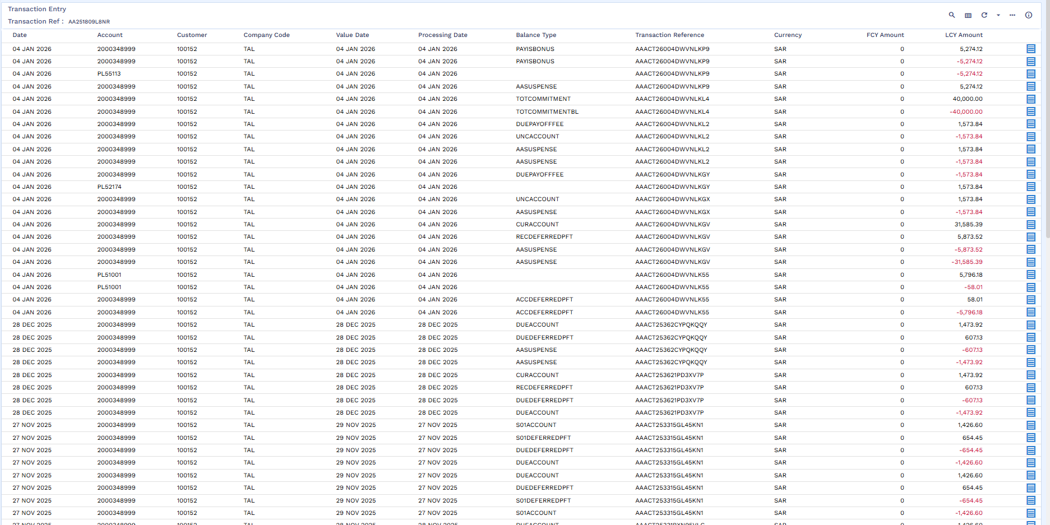
Accounting Entries

